Wendy Galarza – MEXICO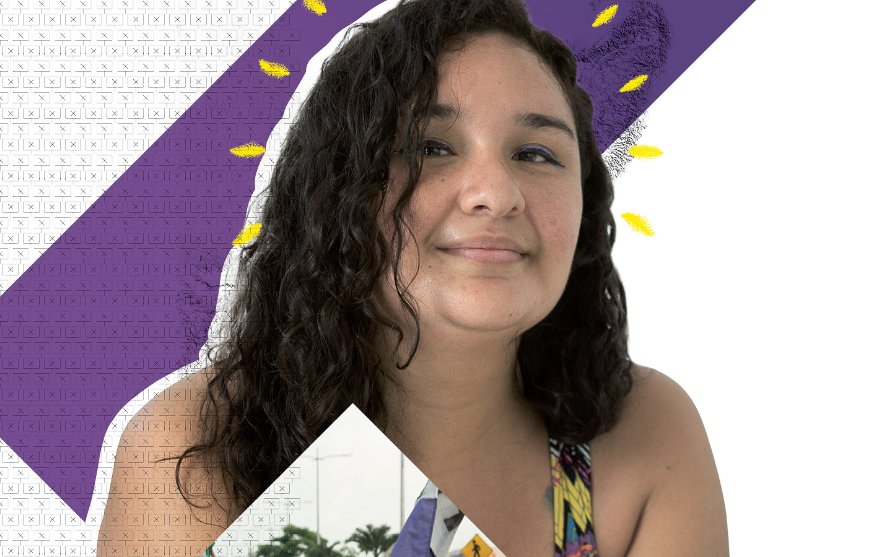

Shot while protesting violence against women
Wendy Galarza is a dedicated childcare worker. She’s passionate about supporting children in their youngest years, because she believes it’s the best way to create kinder and more compassionate societies.
It’s a goal Wendy works hard for in Mexico, where women are often degraded, attacked and killed for being women. A feminist activist, she, too, almost lost her life for denouncing such violence.
On 9 November 2020, Wendy attended a march organised by feminist collectives in Cancún to demand justice for the murder of a woman known as Alexis. But when a group of demonstrators began pulling down and burning some wooden barriers, police fired shots into the air and, some say, into the crowd. Later, Wendy discovered she had bullet wounds in her leg and vulva.
Two days later, she lodged a complaint against the police. It took months for the State Prosecutor to accept her additional evidence, which included clothing showing bullet holes from the day of the protest. Today, the case continues. Those suspected of criminal responsibility for her shooting have not been brought to justice.
Undeterred, Wendy set up a collective with other women who were assaulted during the protest. “I will never let 9 November be forgotten,” she says. “I will continue to raise my voice and defend the human rights of myself and my partners in struggle.”
Demand justice for Wendy from Mexico’s authorities.

For Wendy Galarza, helping to raise young children is the best way to create a fairer world. It’s a goal she works hard for in Mexico, where women are often abused and killed for being women. In November 2020, she joined a march protesting the murder of a woman known as Alexis. During it, police fired shots and Wendy was wounded. She launched a case against the police, but those responsible for the violence have not been brought to justice.
Write to Mexico’s authorities
Tell them to quickly, impartially and thoroughly investigate the violations that Wendy suffered, and ensure that all those responsible are brought to justice.

Attorney General of Quintana Roo
Av. Adolfo López Mateos No.500, esquina Nápoles
Colonia Italia, C.P. 77035
Chetumal, Quintana Roo, México
Email: fiscal.general@fgeqroo.gob.mx
Twitter: @FGEQuintanaRoo
Sample letter
Wendy Galarza – Mexico

Attorney General of Quintana Roo
Av. Adolfo López Mateos No.500, esquina Nápoles
Colonia Italia, C.P. 77035
Chetumal, Quintana Roo
México

Dear Attorney General
Wendy Galarza is a dedicated childcare worker. Through her work, she strives to create a kinder and more compassionate society. It’s an especially important goal in a context where women are often abused and killed for being women.
On 9 November 2020, Wendy, too, nearly lost her life to such violence. She attended a feminist march in Cancún where police fired shots and she was wounded. She launched a case against the police, but those responsible for the violence have not been brought to justice. Show Wendy that you take violence against women seriously. Impartially and thoroughly investigate the violations that she suffered, and ensure that all those responsible are brought to justice.
Yours sincerely

Solidarity action
Show Wendy you’re with her
Write a message of support to Wendy, telling her how much you admire her for standing up for the rights of women, and expressing solidarity with her fight for justice.
Post your message on Twitter, mentioning @ShoutForWendy and using the hashtag #ShoutForWendy or #GritoPorWendy. Photos of handwritten messages are more personal and would help to bolster Wendy’s resolve.

