Mohamed Baker – EGYPT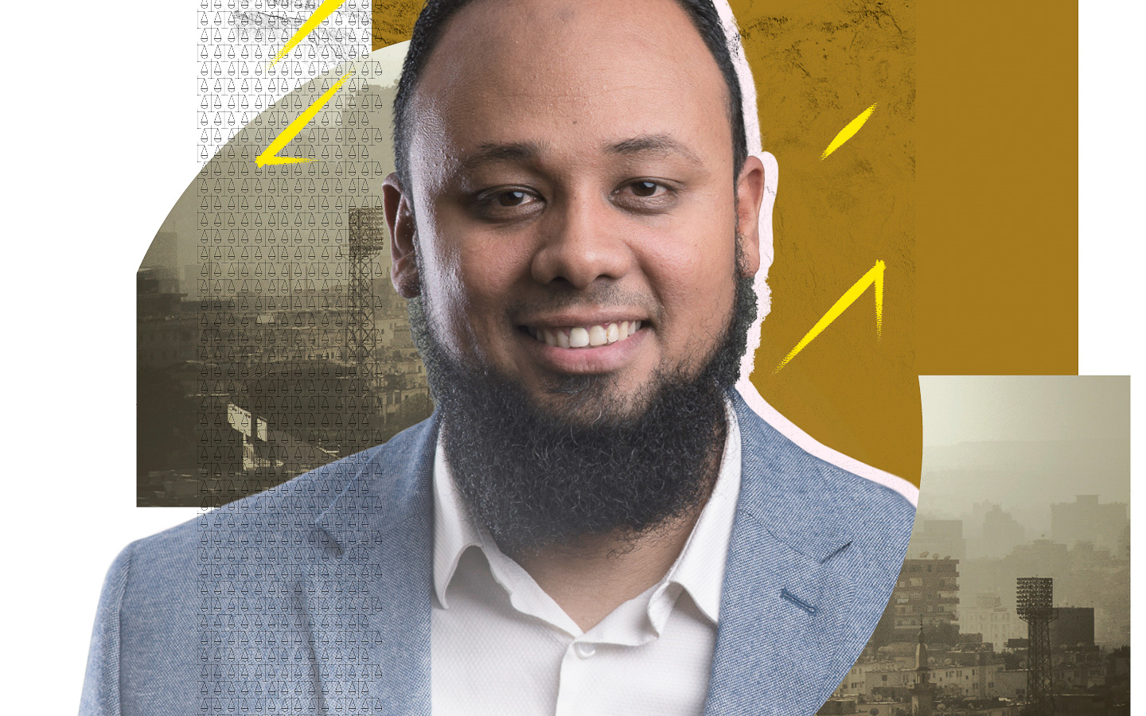
HE DEFENDED FREEDOM, THEY TOOK HIS AWAY
Mohamed Baker loves cats so much, he has five of them. A football fan, he’s also into squash and motorbike riding. Baker, himself a Nubian, also enjoys Nubian music and culture. But today, the human rights lawyer can only dream of what he loves. He’s in prison for defending some of the most marginalized people in Egypt.
In September 2019, he went to the prosecutor’s office to defend his friend and was himself arrested. Baker has spent over two years in detention without being charged or put on trial. Then authorities referred him to trial by an emergency court on “false news” charges but it is clear that he is being punished because of his human rights work. Baker heads the Adalah Center for Rights and Freedoms, which supports human rights and people jailed unjustly.
In jail, the authorities have subjected Baker to one cruelty after another. They didn’t let him see his dying father. They’ve kept him in a cramped, fetid cell. And they’ve deprived him of a bed or mattress, hot water, outdoor exercise and even family photos.
Still Baker is hopeful. “One day… we will continue our work [to establish] free societies,” he says. Help bring that day forward.
Tell Egypt to release Baker immediately.

Human rights lawyer Mohamed Baker must do without his wife, cats, and everyone else he loves. Falsely charged with “false news” charges, he’s in prison for defending the rights of some of the most marginalized people in Egypt. The prison authorities have treated him especially cruelly, refusing him a bed, mattress, outdoor exercise, even family photos. Defending people’s freedoms should not cost him his own.
Write to Egypt’s authorities
Tell them to release Mohamed Baker immediately and unconditionally, and to drop all charges against him.

The President
Office of the President
Al Ittihadia Palace
Cairo, Arab Republic of Egypt
Fax +202 2391 1441
Email: p.spokesman@op.gov.eg
Twitter: @AlsisiOfficial
Sample letter
Mohamed Baker – Egypt

The President
Office of the President
Al Ittihadia Palace
Cairo
Arab Republic of Egypt

Dear President
As a human rights lawyer, Mohamed Baker helps the people who need him most – those who have been marginalized and jailed unfairly. Now Baker himself has been locked up and unjustly charged with “false news” charges. He was thrown in jail where prison authorities are confining him to his cell round the clock and cruelly refusing him a bed, mattress, books, newspapers – even family photos.
Defending people’s freedoms should not cost him his own. I ask that you release Mohamed Baker immediately and unconditionally, and to drop all charges against him.
Yours sincerely

Solidarity action
Help keep Baker’s spirit strong
Post your messages of friendship and solidarity for him on Twitter or Facebook using the hashtags: #Free_Baker / #الحرية_لباقر
Don’t forget to follow/like the following accounts to show your support:
Twitter: @FreeBaker2
Facebook: Free Baker https://www.facebook.com/freebaker

