Zhang Zhan – CHINA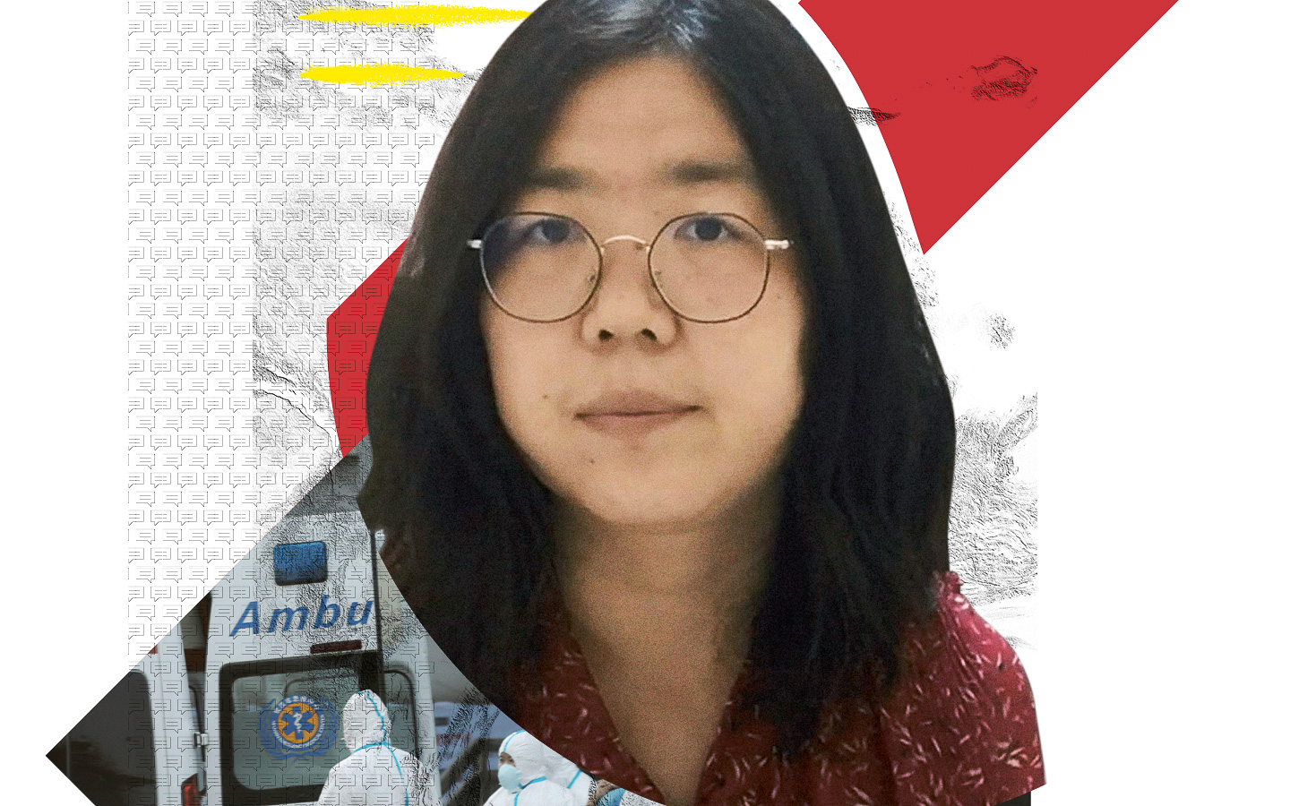
SHE DARED TO REPORT THE TRUTH ABOUT COVID-19 IN CHINA
When Wuhan – then the centre of the Covid-19 outbreak in China – went into lockdown, Zhang Zhan was one of the few citizen journalists to report on the unfolding crisis.
Determined to get the truth out, the former lawyer travelled to the beleaguered city in February 2020. She took to social media, reporting how government officials had detained independent reporters and harassed families of Covid-19 patients. Citizen journalists were the only source of uncensored, first-hand information about the epidemic.
Working independently of state-controlled media, citizen journalists face constant harassment for exposing information the government would rather keep quiet.
Zhang Zhan went missing in Wuhan in May 2020. Authorities later confirmed that she had been held by police in Shanghai, 640km away. In June 2020, she began a hunger strike to protest her detention. In December, her body was so weak she had to attend her court hearing in a wheelchair. The judge sentenced her to four years in prison for “picking quarrels and provoking trouble”.
Zhang Zhan was transferred to Shanghai Women’s Prison in March 2021. The authorities continue to refuse her family visits. “We should seek the truth and seek it at all costs,” Zhang Zhan has said. “Truth has always been the most expensive thing in the world. It is our life.”
Tell China to free Zhang Zhan immediately.

When Wuhan went into lockdown, Zhang Zhan was one of the few citizen journalists to report on the unfolding Covid-19 crisis. Determined to get the truth out, the former lawyer travelled there in February 2020. She took to social media to report how government officials had detained independent reporters and harassed families of Covid-19 patients. She was later detained and sentenced to four years in prison to silence her.
Write to China’s authorities
Tell them to release Zhang Zhan immediately and unconditionally.

President of the People’s Republic of China
Zhongnanhai
Xichang'anjie
Xichengqu, Beijing Shi 100017
People’s Republic of China

Email: english@mail.gov.cn
Sample letter
Zhang Zhan – China

President Xi Jinping
President of the People’s Republic of China
Zhongnanhai
Xichang’anjie
Xichengqu, Beijing Shi 100017
People’s Republic of China

Dear President Xi
Zhang Zhan typifies the courage of investigative journalists who speak truth to power. Citizen journalists like her were the only source of uncensored, independent, and first-hand information about the coronavirus outbreak, publishing reports on social media and the internet despite constant harassment and repression. Yet, instead of being praised, Zhang Zhan received four years’ imprisonment for daring to report what she saw. If the Chinese authorities are serious about combating Covid-19 and preventing similar outbreaks from happening again, they must stop censorship and respect freedom of expression – free Zhang Zhan immediately and unconditionally.
Yours sincerely

Solidarity letter
Show Zhang Zhan she’s not alone
Send her a message of hope, such as:
Zhang Zhan, your dedication to reporting the truth will continue to inspire others.
We will continue to support you and look forward to the day you regain freedom.
Keep your spirits up!

Simplified Chinese:
张展，您对报导真相的坚持将会继续激励他人。
我们会继续支持和关注您。
我们期待您重获自由的一天。
加油！

Zhang Zhan
No 1601, Zhangjing Road, Sijing Zhen
Songjiang Qu, Shanghai 201601
People’s Republic of China
*To increase the chances of Zhang Zhan actually receiving your message, please do not mention Amnesty International anywhere in it.

For social media, please use:
#ZhangZhan #张展
#FreeZhangzhan #释放张展

