Mikita Zalatarou – BELARUS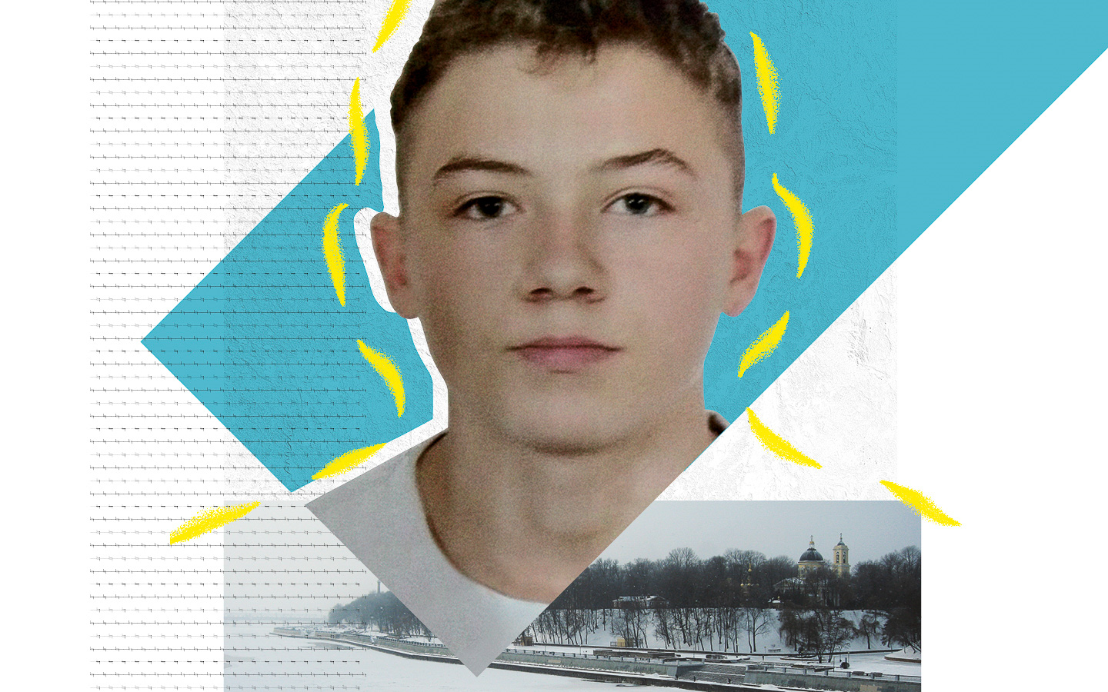
Assaulted and jailed after an unfair trial
Until recently, Mikita Zalatarou was a typical teenager. He liked playing Minecraft and listening to rap music. Today, the 17-year-old who also has epilepsy has been cast into a world worse than Minecraft’s hellish Nether.

It all began in August 2020, says Mikita’s dad, when Mikita was waiting for a friend in the main square of Homel city, south-eastern Belarus. Nearby, people had been largely peacefully protesting the recent presidential election results when police moved in. According to Mikita’s father, as the crowd began running, someone told Mikita to run, too – so he did.

The following day – 11 August – police officers came to Mikita’s door. They arrested him, beating him and accusing him of throwing a Molotov cocktail towards two officers the night before. While holding him in custody, they beat him with an electric shock truncheon. Officers interrogated him without a lawyer or responsible adult present, and locked him up for six months before putting him on trial.

Mikita was convicted of mass disorder and using illegal explosives, yet video evidence did not show him taking part in violence. Media reports on the demonstrations mentioned no mass unrest. Still, the judge sentenced Mikita to five years in a child educational prison colony.
Tell Belarus to release Mikita and give him a fair trial.

Mikita Zalatarou was waiting for a friend when he was swept up in a crowd of protesters and straight into a nightmare. Within 24 hours, officers arrested the 16-year-old at his home, accusing him of throwing a Molotov cocktail at riot police. They locked him up and allegedly tortured him. Despite a lack of evidence, Mikita – who also has epilepsy – was convicted and jailed for five years.

Write to Belarus’ authorities
Tell them to release Mikita and ensure he gets a fair trial that meets international justice standards for children.

Prosecutor General of the Republic of Belarus
Ul. Internatsionalnaya 22
220030 Minsk
Belarus
Email: info@prokuratura.gov.by
Facebook: https://www.facebook.com/prokuraturaby
Twitter: @prokuraturaby

Sample letter

Mikita Zalatarou – Belarus

Prosecutor General of the Republic of Belarus
ul. Internatsionalnaya 22
220030 Minsk
Belarus

Dear Prosecutor General
Mikita Zalatarou was waiting for a friend on the street in Homel when he was swept into a crowd of protesters on 10 August 2020. Within 24 hours, the 16-year-old – who also has epilepsy – was in police custody, accused of throwing a Molotov cocktail. Officers beat him, electrocuted him, interrogated him without a lawyer or responsible adult present, and locked him up for six months before putting him on trial. Despite no evidence showing Mikita had been involved in any violence, he was convicted and sentenced to five years’ imprisonment.
Please do all in your power to ensure that he is released pending a fair trial that meets international child justice standards.
Yours sincerely

Solidarity action
Show Mikita you’re with him
Send him your messages of solidarity and friendship. If you’re into Minecraft like Mikita, try creating environments that symbolize freedom and hope in the game, print them out, and send them to him.
Educational Colony V.K – 2
ul. Batova 4
Bobruisk
213800 Mogilevskaya Obl.
Belarus

