Janna Jihad – OCCUPIED PALESTINIAN TERRITORIES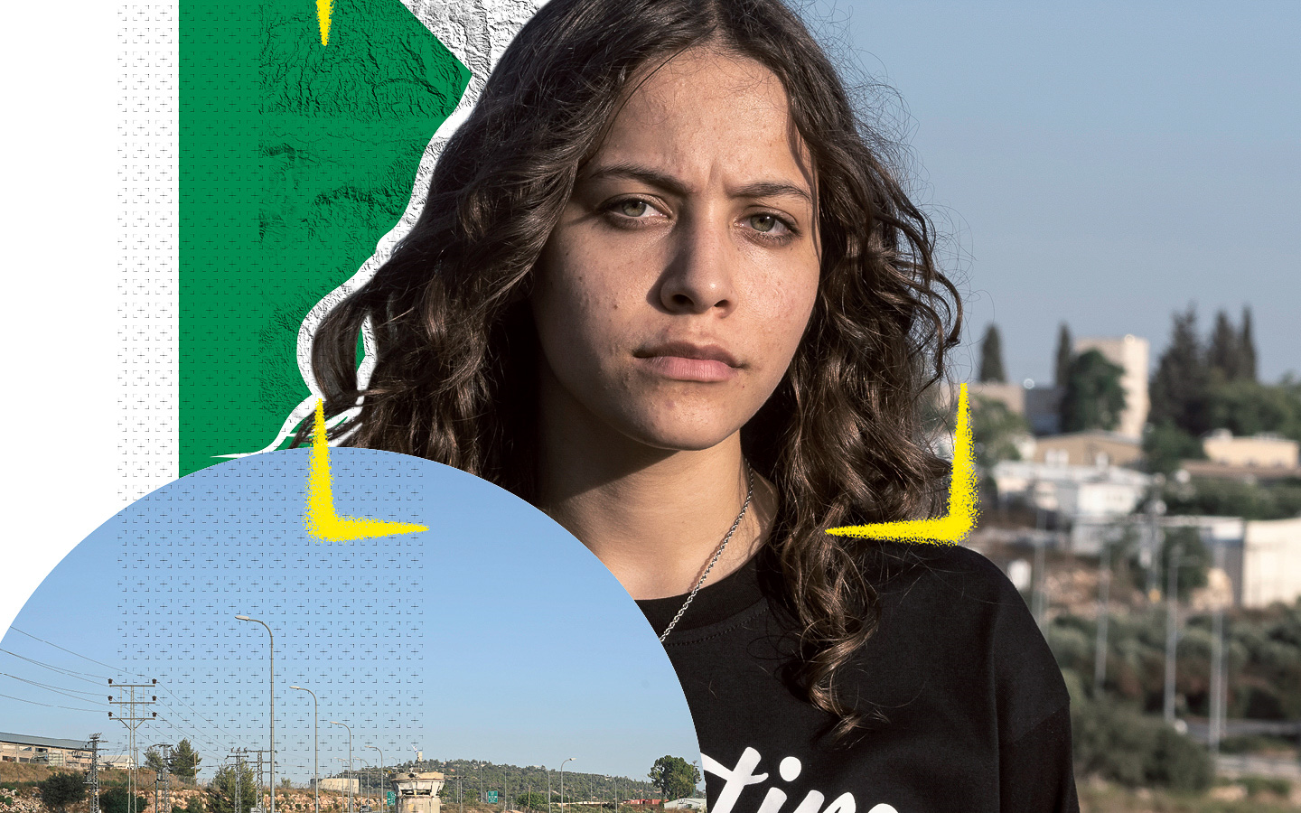

HARASSED FOR EXPOSING ISRAELI VIOLENCE
Janna Jihad just wants a normal childhood. “Like any other child… I want to be able to play soccer with my friends without having tear gas canisters rain on us,” she says. But 15-year-old Janna lives in the Israeli-occupied West Bank. Life under systematic discrimination is anything but normal.

When Janna was seven, the Israeli military killed her uncle. Janna used her mother’s phone to record and expose to the world the racist brutality her community experiences at the hands of Israeli forces. At 13, Janna was recognized as one of the youngest journalists in the world, documenting the Israeli army’s oppressive and often deadly treatment of Palestinians.

This includes night raids, demolishing homes and schools, and crushing communities who stand up for their rights. Palestinian children are particularly affected. Many have been killed and injured by Israeli forces. Israel has signed up to the Convention on the Rights of the Child, yet has failed to extend those protections to Palestinian children in the West Bank. By contrast, Israeli children are protected – even those living in illegal settlements near Janna.

Today, Janna’s principled journalism has marked her out for harassment and death threats. She won’t give up. “I want to know what freedom means in my homeland, what justice and peace and equality means without facing systematic racism,” she says. Let’s help her get there.

Tell Israel to protect Janna from discrimination and violence.

Janna Jihad just wants a normal childhood for herself and all other Palestinian children. But the 15-year-old Palestinian teen lives in the Israeli-occupied West Bank – and life under systematic discrimination is anything but normal. Having begun documenting military violations at the age of seven, Janna’s principled journalism has attracted unwanted attention. She’s been harassed and threatened with death, but she won’t give up – not until institutional racism against Palestinians ends.
Write to Israel’s authorities
Tell them to end discrimination against Janna, and to protect her and other Palestinian children as required by the Convention on the Rights of the Child.

Chair, Committee for the Rights of the Child
The Knesset
Committee for the Rights of the Child
Kiryat Ben Gurion
Jerusalem, Israel 9195016

Email: v_yeled@knesset.gov.il

Sample letter

Janna Jihad – Occupied Palestinian Territories

Chair, Committee for the Rights of the Child
The Knesset
Committee for the Rights of the Child
Kiryat Ben Gurion
Jerusalem, Israel 9195016

Dear Member of Knesset
Janna Jihad just wants a normal childhood. But the 15-year-old lives in the Israeli-occupied West Bank, where systematic discrimination and oppression are the norm. Having seen her own uncle killed by the Israeli military, Janna has been thrust into the world of citizen journalism, documenting and exposing the Israeli army’s oppressive and often deadly treatment of Palestinians, including children. Israel has signed up to the Convention on the Rights of the Child, yet doesn’t extend those protections to Palestinian children in the Occupied Palestinian Territories.
Today, Janna’s principled journalism has marked her out for harassment and death threats. I call on you to end discrimination against Janna, and to meet your obligations under the Convention by protecting her and other Palestinian children from harm.
Yours sincerely

Solidarity action
Show Janna you stand by her
Write her a message of solidarity and hope. Take a photo of it and post it to her Facebook page, then mail it to the postal address below.
Facebook: https://www.facebook.com/Janna.Jihad
Amnesty International
6 Ibn Jubair Street
Sheikh Jarrah
PO BOX 42626
Jerusalem, Israel

