Imoleayo Michael – NIGERIA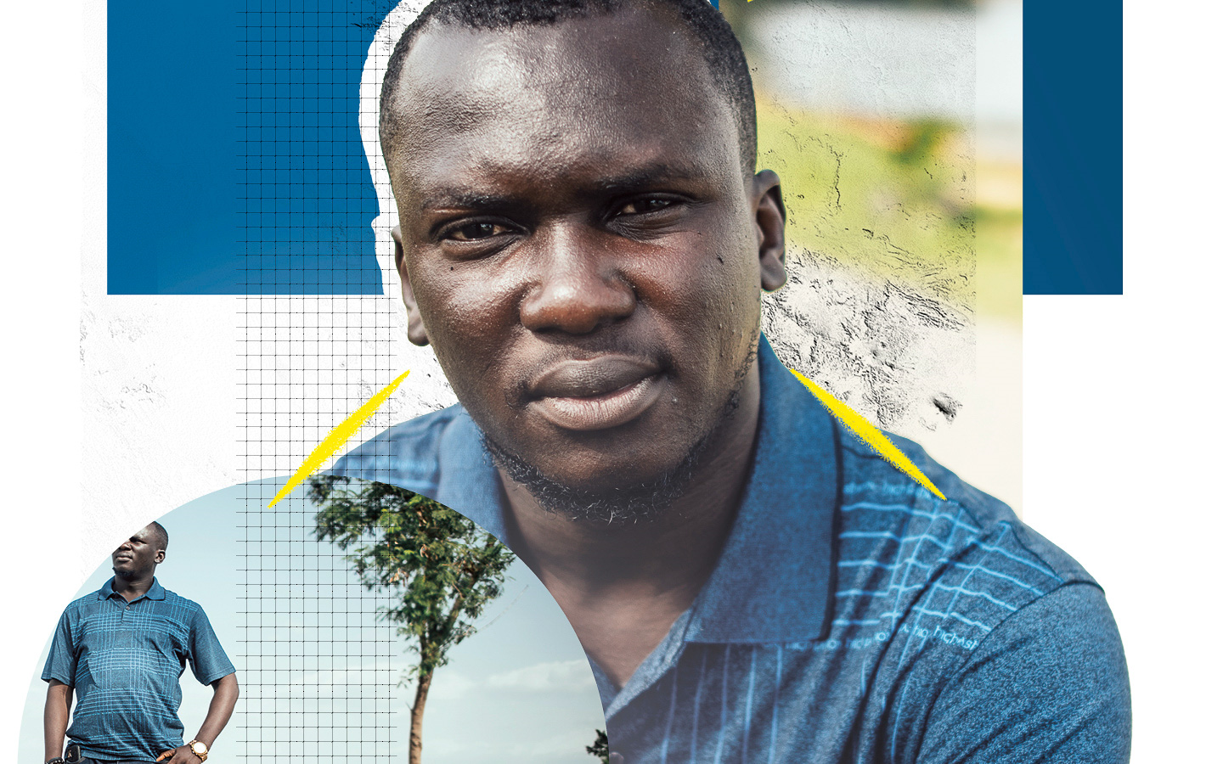
Locked in an underground cell for protesting police violence
When young people took to Nigeria’s capital Abuja in October 2020, Imoleayo Michael joined them. They were marching against violence, extortion and killings by the Special Anti-Robbery Squad, popularly known as SARS. The young computer programmer promoted the protests on Twitter and Facebook, using the viral hashtag #EndSARS.

Two weeks later, in the early hours of 13 November, 20 armed men raided Imoleayo’s home. They shattered his bedroom window and pointed a gun at him, forcing him to open his front door. Once inside, they seized his mobile phones and computer, then locked his wife, elderly mother and seven-month-old son in a room and disconnected the power supply to the streetlights around his house.

They took Imoleayo to state security service headquarters where they held him in an underground cell for 41 days without access to a lawyer or his family. While there, he was cuffed, blindfolded and chained to a steel cabinet. He was also forced to sleep on a bare floor. All he had to eat was some porridge mixed with stones. Security officers interrogated him a total of five times.

Imoleayo suffered pneumonia and was eventually released on bail in December 2020. He’s facing trumped-up charges of ‘conspiracy with others to disturb public peace’ and ‘disturbing public peace’.

Tell Nigeria to drop all charges against Imoleayo.

When young people took to Nigeria’s streets in October 2020, Imoleayo Michael joined them. They were protesting against the Special Anti-Robbery Squad – or SARS – a police unit notorious for violence. The young computer programmer promoted the protests on social media, using the hashtag #EndSARS. Two weeks later, armed men took him from his home and locked him in an underground cell for 41 days. He’s facing trumped-up charges and years in prison.

Write to Nigeria’s authorities
Tell them to drop all charges against Imoleayo immediately.

Attorney General of the Federation and Minister of Justice
Ministry of Justice
New Federal Secretariat Complex
5th Floor, Shehu Shagari, Way Maitama
P.M.B 192 Garki, Abuja
Nigeria
Email: info@justice.gov.ng

Sample letter
Imoleayo Michael – Nigeria

Attorney General of the Federation and Minister of Justice
Ministry of Justice
New Federal Secretariat Complex
5th Floor, Shehu Shagari Way, Maitama
P.M.B 192 Garki
Abuja
Nigeria

Honourable Attorney General of the Federation
Imoleayo Michael is a young computer programmer who only wants a fairer, more just Nigeria. In October 2020, he joined other young people who were protesting against the Special Anti-Robbery Squad – or SARS – a police unit notorious for violence, extortion and killings. Two weeks later, armed men took him from his home and locked him in an underground cell for 41 days. He’s facing trumped-up charges and years in prison, all because he believes that Nigeria’s police can do better for the people they are meant to protect. I urge you to drop all charges against Imoleayo immediately.
Yours sincerely

Solidarity action
Show Imoleayo he’s not alone
Write him a message of friendship and support. Take a photo of it and post it on your social media channels, tagging him as shown below and using the hashtag #FreeImoleAyo.
Twitter: @imoleayomichael (tag @AmnestyNigeria)
Facebook: https://www.facebook.com/adeyeun (tag@ainigeria)

