Ciham Ali – ERITREA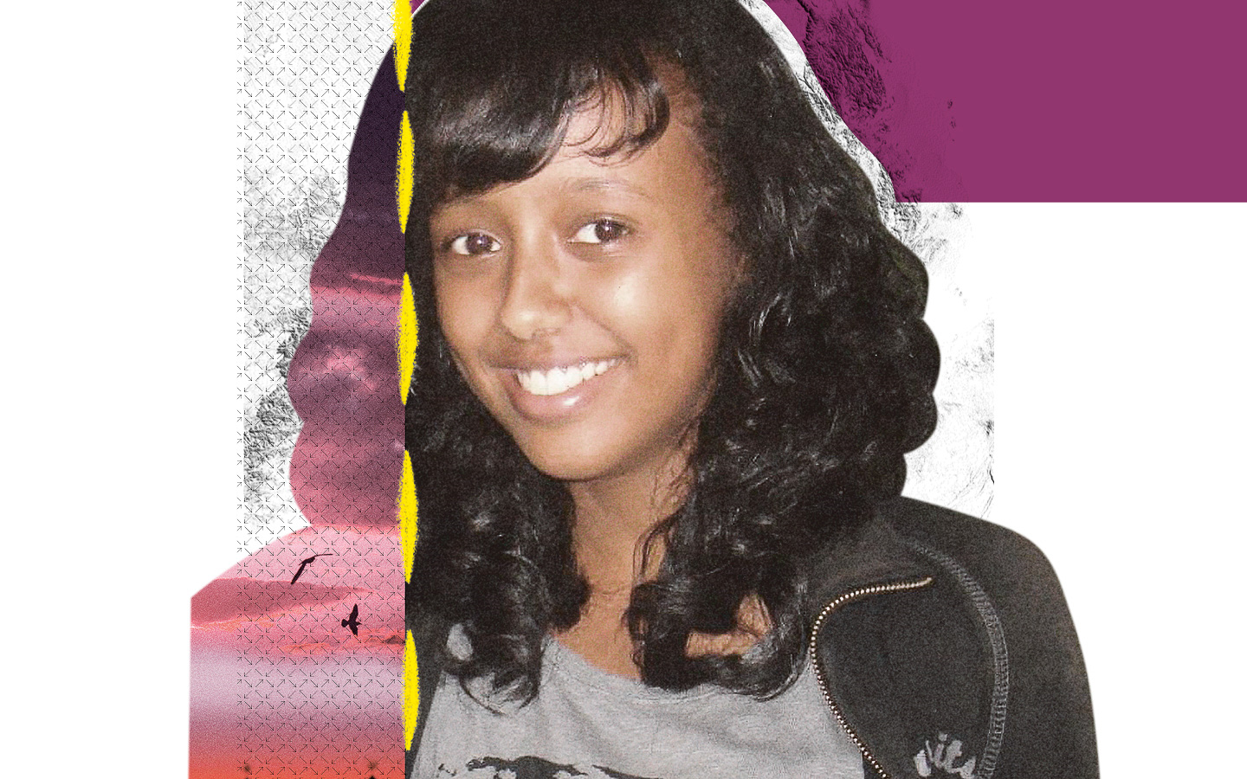
Vanished after being taken by police
Born in Los Angeles and raised in Eritrea, Ciham Ali had big dreams. A fan of Lady Gaga and Green Day, she was determined to become a fashion designer when she grew up. But at 15, her hopes were shattered.
On 8 December 2012, Ciham was arrested at the Sudan border as she tried to flee Eritrea. Her father Ali Abdu, then Minister of Information under President Isaias Afwerki, had gone into exile just as the military attempted a coup against the government. The rumour was that Ali Abdu had supported the coup and Ciham may have been arrested in retaliation.
Nine years on and no one – not even her family – knows where Ciham is being held. She hasn’t been charged, nor has she been brought to trial. It’s as if she’s vanished. Eritrea is notorious for imprisoning people in underground containers where they suffer extreme cold and heat. There are reports of many people dying from torture, starvation, infection and other appalling treatment in these jails. While other children her age might have headed to college, Ciham has been suffering unknown horrors.
Although she’s a US citizen, Ciham has been ignored by the US government. So far, they’ve remained silent on her plight, even though they have the power to influence Eritrea.
Tell the USA to speak out for Ciham.
Born in Los Angeles and raised in Eritrea, Ciham Ali wanted to be a fashion designer. But at 15, her ambitions were cut short when she was arrested trying to flee Eritrea – and never seen again. The authorities appear to have taken her in retaliation against her father’s suspected involvement in a coup attempt on the government. Nine years on and no one knows where Ciham is being held. Meanwhile, the US government has been silent on their citizen’s plight.
Write to the US authorities
Tell them to demand Ciham’s immediate and unconditional release.

Sample letter:

US Secretary of State
2201 C Street NW
Washington, DC
20520
U.S.A
Twitter/ Instagram: @SecBlinken

Dear Secretary of State,
Ciham Ali, a US citizen born in Los Angeles and raised in Eritrea, has been missing since 8 December 2012. The teenager who dreamt of becoming a fashion designer was arrested at the Eritrean border when she was 15. Her arrest appears to be in retaliation against her father’s suspected involvement in a coup attempt on the Eritrean government. Nine years on and no one knows where Ciham is. Eritrea is notorious for imprisoning people in underground containers where they torture, starve or even kill them. The US government must act now. Please use your influence and speak out for Ciham: demand her immediate and unconditional release.
Yours sincerely

Solidarity action:
Help Ciham’s family keep their hopes alive
Take a picture of yourself wearing anything purple – Ciham's favourite colour – and post it on social media to show solidarity with Ciham and her family. Use the hashtag #Purple4Ciham and tag Secretary Blinken!

