Bernardo Caal Xol – GUATEMALA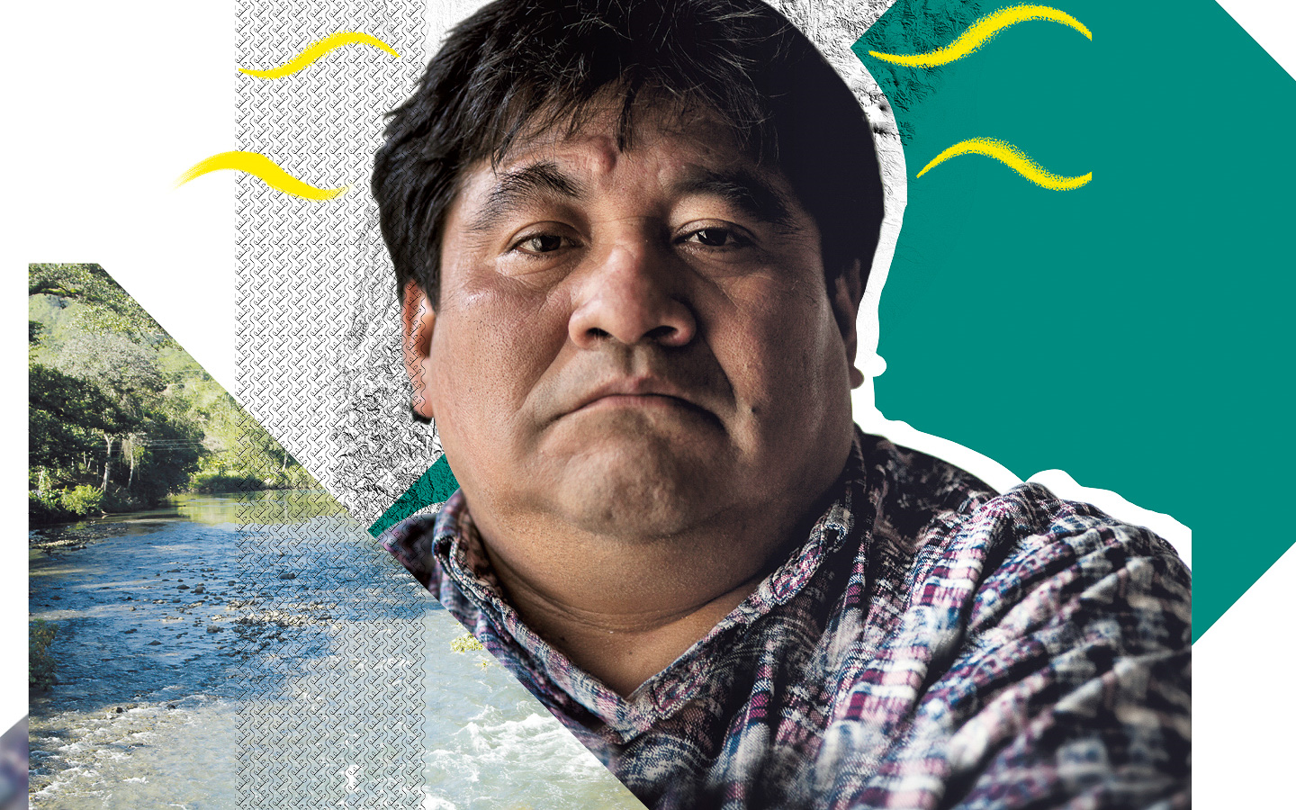
JAILED FOR DEFENDING A SACRED RIVER
Bernardo Caal Xol holds a whole people in his heart. Through his teaching and trade union leadership, he has made it his mission to empower his people, the Indigenous Maya Q’eqchi’ in north central Guatemala. He has also done everything he can to peacefully protect their land and natural resources from plunder and biodiversity loss.
So, when a company licensed by the government dammed the Maya Q’eqchi’s Cahabón river to build two hydroelectric power plants, Bernardo and his people protested. The river is one of the longest in Guatemala, and is sacred to the Maya Q’eqchi’. Construction of the power plants had already stripped their forests; now they were losing the precious water they needed to survive. Bernardo demanded a stop to the power plants’ activities, saying the authorities had failed to properly consult his people – a requirement under international law.
But his actions put him at odds with the company, and economic and political elites. Bernardo was publicly smeared with repeated and baseless accusations. In 2018, a judge sentenced him to more than seven years in prison, convicting him without any evidence.
“Why am I in jail?” Bernardo asks. “For denouncing what they are doing to the rivers, defending what little is left.”

Write to Guatemala’s authorities
Tell them to drop all charges against Bernardo and free him immediately.

Attorney General of Guatemala
Email: carrecis@mp.gob.gt
Twitter: @MPguatemala
Facebook: @mpguatemala
Sample letter

Attorney General of Guatemala / Fiscal General de Guatemala
Public Prosecutor's Office / Ministerio Público
15 Avenida A 15-16, Ciudad. de Guatemala
Guatemala

Dear Attorney General,
Bernardo Caal Xol holds a whole people in his heart. He and the Maya Q’eqchi are a vital part of Guatemala’s heritage. They are peacefully protecting the land and water that make the country a unique place. Yet the hydro-electric power plants licensed to operate without their permission are disrupting their sacred Cahabón river, scarring the landscape, and destroying their way of life.
Bernardo only wants to ensure that the land and water are preserved for the future, yet he has been smeared with baseless accusations and imprisoned for more than seven years on sham charges. I urge you to drop all charges against Bernardo and free him immediately.

Yours sincerely

Solidarity action
Show Bernardo you’re with him
Send your messages of hope and solidarity, so Bernardo knows he’s not alone in his struggle to protect his people’s lands.
Bernardo Caal Xol
Oficina Regional de Amnistía Internacional
Luz Saviñón 519
Colonia del Valle
Alcaldía Benito Juárez
03100, Ciudad de México
México

Twitter: @BernardoCaal2
Facebook: @bernardo caal xol
Email: hrdamericas@amnesty.org

