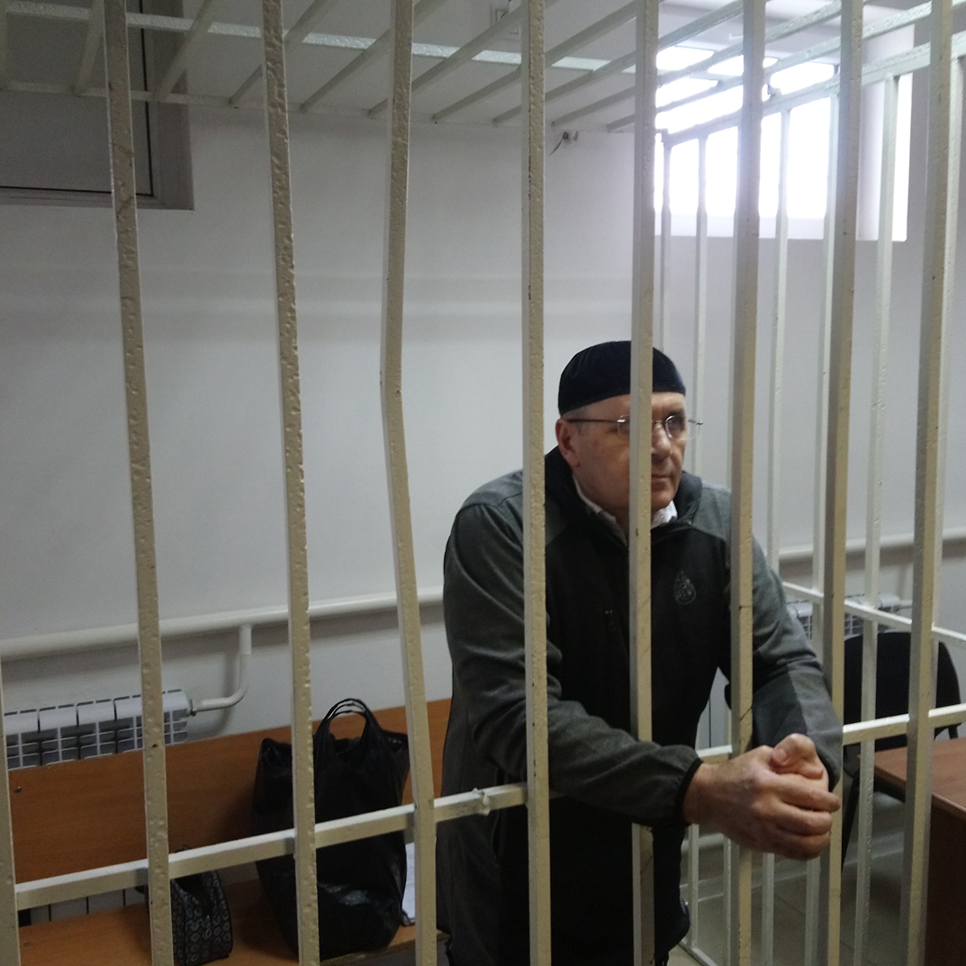
unfair game:
persecution of human rights defenders in RUSSIA INTENSIFIES

Amnesty International is a global movement of more
than 7 million people who campaign for a world
where human rights are enjoyed by all.
Our vision is for every person to enjoy all the rights
enshrined in the Universal Declaration of Human Rights
and other international human rights standards.
We are independent of any government, political
ideology, economic interest or religion and are funded
mainly by our membership and public donations.

contents

1. INTRODUCTION 4
2. THREATS AND VIOLENCE AGAINST HUMAN RIGHTS DEFENDERS 5
2.1 ATTACK ON ENVIRONMENTALIST ANDREY RUDOMAKHA AND HIS COMPANIONS 6
2.2 ASSAULTS ON DINAR IDRISOV 7
2.3 THREATS TO IRINA BIRYUKOVA 8
2.4 ATTACKS AGAINST LESBIAN, GAY, BISEXUAL, TRANSGENDER AND INTERSEX ACTIVISTS 8
2.5 ATTACKS AGAINST HUMAN RIGHTS DEFENDERS IN THE NORTH CAUCASUS 9
2.6 CAMPAIGN AGAINST THE HUMAN RIGHTS CENTRE MEMORIAL IN THE NORTH CAUCASUS 10
2.7 DEATH THREATS AGAINST IGOR KOCHETKOV 11
3. FABRICATED CRIMINAL CHARGES AGAINST HUMAN RIGHTS DEFENDERS 12
4. THE USE OF LEGISLATION TO OBSTRUCT AND DISCREDIT HUMAN RIGHTS WORK 18
5. CONCLUSION AND RECOMMENDATIONS 23

- INTRODUCTION

Defending human rights in Russia has become ever more dangerous in recent years. Human rights defenders have long faced harassment, intimidation, physical attacks and arbitrary arrests because of their work. However, the level, extent and complexity of the obstacles they face have increased significantly, to the point that human rights work now entails greater risks for defenders, including attacks on their personal reputation, physical integrity and freedom.
Always a dangerous occupation, the situation of human rights defenders in Russia has deteriorated significantly since 2012, the year Vladimir Putin began his third presidential term. The Russian authorities responded to a wave of public protests against alleged electoral irregularities in 2011-2012 by passing a series of laws that impose severe restrictions on the rights to freedom of association, peaceful assembly and expression.
They have also sought to discredit individuals and NGOs involved in human rights work. Several mainstream media providers in Russia have mounted a smear campaign against human rights defenders, portraying them as people working for foreign paymasters to undermine the country’s security and “traditional values”.
Criminal proceedings have been launched against several prominent human rights defenders, some of whom have been convicted and imprisoned. At the same time, human rights defenders have been the targets of routine physical attacks and death threats, including from senior officials, particularly in the North Caucasus. Neither the attacks nor the threats have been effectively investigated. This raises concerns regarding the lack of political will, including at the highest levels of power, to address this issue. Not only do the perpetrators of these offences evade justice, but possible official complicity in these crimes is not addressed. Whether perpetrated directly by officials or tolerated through inaction and impunity, they constitute human rights violations for which the Russian authorities bear responsibility.
This document, which draws on interviews with human rights defenders, trial observations and desk research, provides a brief overview of the current situation of human rights defenders in Russia and includes illustrative cases that show the very real obstacles and dangers they face.
The current treatment of human rights defenders in Russia represents a clear violation of a range of human rights which Russia has committed itself to respect, protect and fulfil. This document sets out what the Russian authorities must acknowledge, and what they must do to ensure that they put an end to these violations and fulfil their human rights obligations.

- THREATS AND VIOLENCE AGAINST HUMAN RIGHTS DEFENDERS
“The State shall take all necessary measures to ensure the protection by the competent authorities of everyone, individually and in association with others, against any violence, threats, retaliation, de facto or de jure adverse discrimination, pressure or any other arbitrary action as a consequence of his or her legitimate exercise of the rights referred to in the present Declaration.”
Article 12 (2) of the UN Declaration on Human Rights Defenders

Physical attacks and the intimidation of people because of their human rights work have become increasingly common in Russia. Since 2012, there have been dozens of attacks against human rights defenders and civil society activists. In most cases, the victims did not know their assailants. The motivation for the attacks has often been explicit: reprisal for human rights activities. Another worrying and consistent pattern seen in relation to these incidents is the persistent failure of the authorities to investigate them effectively. Indeed, in some cases, the authorities have simply refused to investigate. In other cases, formal investigations were opened but effectively stalled. The circumstances surrounding many of the attacks and the continuing impunity enjoyed by the perpetrators raise concerns about possible official complicity in these crimes.

  - ATTACK ON ENVIRONMENTALIST ANDREY RUDOMAKHA AND HIS COMPANIONS
On 28 December 2017, Andrey Rudomakha, Victor Chirikov, Aleksandr Savelyev, three members of the NGO Environmental Watch for the North Caucasus (EWNC) from Krasnodar region in the south-west of Russia, and Vera Kholodnaya, a local journalist from an independent news website Free Media, were the targets of a vicious attack by three masked men. The assault has yet to be effectively investigated.
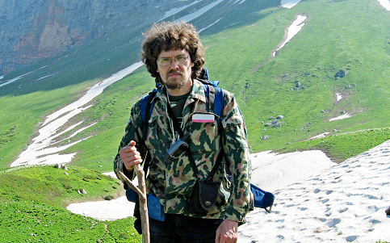 | Andrey Rudomakha, Head of the NGO Environmental Watch for the North Caucasus © Private

On the evening of the attack, the group had just returned from the site of a reported illegal construction in a protected woodland area on the Black Sea coast, which they believe is linked to high-level federal officials. As they were getting out of the car outside the home of one of the activists, three men wearing hooded tracksuits and surgical masks over their faces attacked them from behind. Andrey Rudomakha was attacked with pepper spray, punched and kicked. He was knocked to the ground where the attackers continued to kick him in the face until he lost consciousness. Victor Chirikov was punched in the stomach and both he and Vera Kholodnaya were doused with pepper spray. The assailants stole the activists’ backpacks containing the photos and video cameras used to document the illegal construction and left. Andrey Rudomakha required hospital treatment for the injuries sustained in the attack, which included a fractured skull, broken teeth, several broken bones in his face and chemical burns to his eyes.
The authorities opened a criminal investigation, initially for “premeditated robbery with non-life- threatening violence committed by a group of people”. Later they recategorized it as a more serious crime, “premediated robbery with extreme violence causing grievous bodily harm committed by an organized group”. However, despite appeals by Rudomakha’s colleagues to define this attack as a more serious crime of “attempt on life of a state official or public figure”, the authorities found no grounds to do so.
The authorities have substantive evidence about the attack at their disposal, including CCTV footage and the fingerprints of the assailants. However, more than a year and a half after the incident, the investigation has produced no tangible results and appears to have stalled. Moreover, two weeks after the attack, Andrey Rudomakha and his colleagues received further threats but these were not effectively investigated, and the perpetrators not identified.
In the 20 months that have passed since the attack, the investigation has been suspended and reopened at least four times. In February 2019, Andrey Rudomakha filed a complaint regarding the ineffective investigation of the attack to Krasnodar Oktyabrskii District Court, which considered and rejected it. On 23 July 2019, Krasnodar Regional Court quashed the lower court decision and ordered that Andrey Rudomakha’s complaint must be considered again. On 16 August 2019, Krasnodar Oktyabrskii District Court upheld Andrey Rudomakha’s complaint and found the investigator’s inaction unlawful. It remains to be seen whether the investigation will bring any results.
In correspondence with the Presidential Council for Human Rights, which raised this case, the authorities – specifically the Krasnodar Region’s Prosecutor’s Office – assured that the case was handled as a priority (“under the Prosecutor’s Office control”) and that it supported Andrey Rudomakha’s request for state protection. However, at the time of writing Andrey Rudomakha had received neither further information about the progress of the case, nor state protection.
Andrey Rudomakha and his colleagues believe that the security services may be behind the attack and they are certain that the aim was to stop their investigation into illegal construction and corrupt practices in Krasnodar region.
  - ASSAULTS ON DINAR IDRISOV
On 28 January 2018, human rights defender Dinar Idrisov was beaten by three unidentified men as he was trying to set up a camera to live stream coverage of a mass rally in the centre of St Petersburg.
Dinar Idrisov was looking for a vantage point from which to film. He went into a nearby block of flats and rang the bells of several flats on the top storeys to see if he could film from there, but there was no reply, so he went back downstairs. When he reached the first-floor landing, three men whom he did not know attacked him. According to Dinar Idrisov, he was beaten up “very professionally, and if the first blow into my temple wasn’t a grazing one, it could have led to a fatal outcome.” Dinar Idrisov sustained a number of serious injuries including a head injury, a fractured arm and cheekbone, and several bruises. The attackers also broke his video camera and two mobile phones.
There are numerous CCTV cameras in the area where the attack took place that should have captured images of the assailants. However, according to Dinar Idrisov, the investigation has failed to obtain any relevant footage, allegedly because none of the cameras were working at the time. There is a well-documented pattern in Russia of purportedly faulty cameras in locations which could have captured footage identifying perpetrators allegedly associated with the authorities. (Another example of this can be seen in the case of Oyub Titiev below.) So far, the police have failed to identify any of the attackers. The investigators also failed to share the case file with Dinar Idrisov and his lawyer, thus depriving them of an opportunity to lodge a complaint about police inaction.
Meanwhile, on 6 March 2019, Dinar Idrisov was brutally attacked again. Four unknown men were waiting for him outside the block of flats where he lives. They assaulted him when he arrived and got out of his car. The attackers also stole his phone. Dinar Idrisov had to be hospitalised, requiring specialist medical assistance for his injuries. The police have failed to effectively investigate this latest attack. Dinar Idrisov believes this attack is linked to his human rights work.

  - THREATS TO IRINA BIRYUKOVA
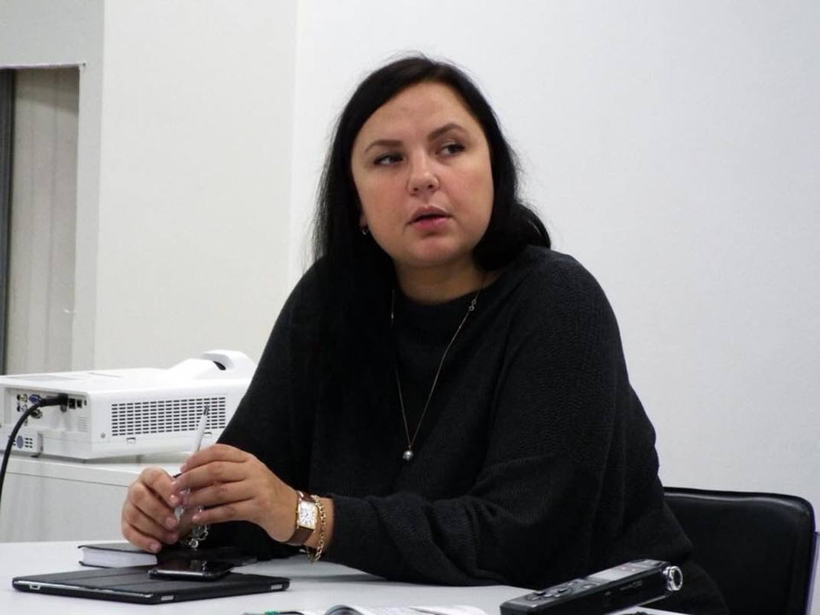 | Irina Biryukova, human rights lawyer © Private

On 20 July 2018, Novaya Gazeta newspaper published a video acquired by human rights lawyer, Irina Biryukova. It featured 10 minutes of non-stop beating and humiliation of a half-naked prisoner by 18 prison officers, at a penal colony in Yaroslavl region in Central Russia. The incident had taken place a year earlier, and Irina Biryukova had reported it to the authorities, but no investigation took place until after the video was published and caused a public outcry.
Immediately after the opening of a criminal case against the alleged perpetrators, Irina Biryukova started receiving death threats, and was compelled to leave the country for several weeks with her daughter. She filed a complaint about the threats to the Investigation Committee and requested state protection (a form of witness and victim protection under Russian law). Despite the fact that the threats continued, the Investigation Committee refused to grant her protection. In its response it acknowledged both the threats and that they were coming from the officers at the penal colony, but stated that these were “not targeted at her personally” and concluded that there was no evidence of any “real threat” to the lawyer or members of her family.
After her return to Russia in September 2018, Irina Biryukova reported being followed by men she believed were former penal colony officers. It was only in November that her request for state protection was finally granted by the authorities. However, no action was taken: the ‘protection’ Irina Biryukova received has been on paper only.
  - ATTACKS AGAINST LESBIAN, GAY, BISEXUAL, TRANSGENDER AND INTERSEX ACTIVISTS
Lesbian, gay, bisexual, transgender and intersex (LGBTI) activists across Russia have repeatedly been the targets of physical attacks for which those responsible have not been brought to justice.
On 3 November 2013, two unidentified men armed with an air gun and baseball bats attacked people taking part in the Rainbow Tea Party event in the offices of LaSky, an LGBTI community centre in St Petersburg. A woman and a man participating in the Tea Party were seriously injured and one, Dmitry Chizhevsky, was blinded in one eye.
The police opened a criminal case under Article 213 (2) of the Russian Criminal Code (“Conspiracy to perform an act of hooliganism committed by a group of people”). In March 2015, the investigation was suspended on the grounds of the authorities’ “inability to identify the suspects”. In the same year, Dmitry Chizhevsky’s lawyer submitted the case to the European Court of Human Rights (ECtHR). The case was communicated to the Russian authorities in 2017.
In May 2018, after several unsuccessful attempts, Dmitry Chizhevsky’s lawyer was finally given access to the case file materials. She found that, in addition to “hooliganism”, two other potential avenues of inquiry were initially considered by the investigating authorities, but not pursued. One was “hooliganism on the grounds of hatred or enmity to the LGBT community”; the other was that “the crime was staged by the participants of the event or representatives of LGBT community in order to attract public and media attention”.
An example of an attack targeting LGBTI people which the authorities have failed to investigate at all took place on 13 April 2015 in Murmansk, when an unidentified gas was sprayed into the office of Maximum, an LGBTI rights organization. The two people who were in the office at the time, including human rights activist Violetta Grudinina, needed hospital treatment due to the effects of the gas. Police were called but took 40 minutes to arrive. The officers were dismissive of the victims’ complaints and did not record the crime or secure any evidence from the scene. Police later refused to open a criminal investigation into this incident. The actions of the police in this case reflect a wider pattern of law enforcement officials appearing to view LGBTI people as second-class citizens and failing to respond to crimes against them with the appropriate degree of concern and thoroughness.
  - ATTACKS AGAINST HUMAN RIGHTS DEFENDERS IN THE NORTH CAUCASUS
Human rights defenders working in the North Caucasus, and especially in Chechnya, such as members of the Russian NGO Committee Against Torture (CAT) and the Joint Mobile Group of Human Rights Defenders for Chechnya (JMG), are in constant, serious, danger. Some, like the Head of the CAT, Igor Kalyapin, have been repeatedly subjected to vicious attacks. The situation has become increasingly serious since 2014, so much so that the JMG relocated its office to the neighbouring Stavropol region.
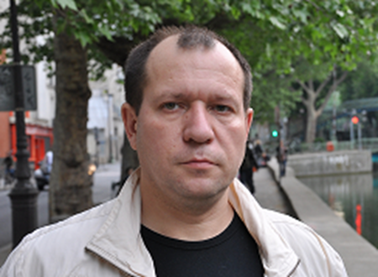 | Igor Kalyapin, Head of the NGO Committee Against Torture © Private

On 11 December 2014, two men shouting slogans in support of the Head of the Chechen Republic Ramzan Kadyrov pelted Igor Kalyapin with eggs at a press conference in Moscow. The press conference had been called by Igor Kalyapin and other human rights defenders to highlight the use of collective punishments by the Chechen authorities against the families of alleged members of armed groups.
Two days later, on 13 December 2014, a rally “against terrorism” took place in the Chechen capital, Grozny. Those taking part – most of whom were civil servants, students and public sector employees – carried placards with slogans attacking human rights defenders, such as: “Kalyapin Go Home $” and “Say ‘No’ to impunity of lying human rights defenders”. After the rally, JMG members in the city were followed by masked men in a Lada Priora car (a type of vehicle often used by local law enforcement officials) and the JMG’s Grozny office was burned down. Some months later, on 3 June 2015, the JMG’s office in Grozny was attacked again when, following another rally in front of the office, a mob of masked men forced their way into the office, destroyed the contents and forced staff to leave.
On 9 March 2016, some 20 masked men attacked a group of human rights defenders and Russian and foreign journalists travelling from Ingushetia to Chechnya. Members of the group were forced to leave the minibus in which they were travelling and then physically assaulted; four of them needed hospital treatment. The minibus was set on fire and completely destroyed. During the attack, the perpetrators shouted abuse, accusing the human rights defenders and journalists of “defending terrorists”. On the same day, the JMG’s office, which had relocated from Grozny to Karabulak in Ingushetia, was ransacked and its contents were destroyed by a group of armed masked men.
A few days later, on 16 March 2016, Igor Kalyapin was attacked by some 15 masked men as he was leaving a hotel in Grozny after the hotel staff told him he was not welcome there. The attackers pelted him with eggs, sprayed him with a green antiseptic liquid and repeatedly hit him. Following this incident, the Kremlin spokesperson Dmitry Peskov acknowledged that the attack on the prominent human rights defender was “unacceptable” and a “dangerous trend that raises concerns”. At the same time he downplayed the seriousness of this attack, as well as the attack on the border with Ingushetia. In a statement that completely ignored the persistent pattern of increasingly violent attacks, he commented that these were committed by “hooligans” and that he “would not exaggerate too much” the situation.
Police repeatedly refused to open criminal investigations into the 2014, 2015 and 2016 attacks against Igor Kalyapin on the grounds of “absence of elements of crime”. He continuously sought judicial review of these refusals, and the courts consistently quashed them as ‘illegal’. Not once was this followed by an investigation. The March 2016 attack on human rights defenders and journalists travelling from Ingushetia to Chechnya is the subject of an official investigation. This has been extended several times, but no suspects have been officially identified to date. According to Igor Kalyapin, in 2017 an investigator assigned to the case called him to ask whether he could arrange a visit from the affected journalists from Sweden and Norway to take part in some investigation procedures, so as to identify suspects. Kalyapin confirmed that he and his colleagues would be happy to organize the visit. The investigator has not contacted him since. The investigators have refused to inform the victims of the attack about the progress, if any, of the investigation.
  - CAMPAIGN AGAINST THE HUMAN RIGHTS CENTRE MEMORIAL IN THE NORTH CAUCASUS
The Human Rights Centre Memorial (Memorial) is one of the few human rights organizations still operating in Chechnya and it is certainly one of the highest profile. For a number of years, members of its staff have faced threats and intimidation. In July 2009, Natalia Estemirova, one of their leading researchers, paid the ultimate price for her courageous work exposing human rights violations in the region. Her killing led Memorial to suspend its activities in Chechnya for several months; they resumed their work there in December 2009. Almost 10 years after the death of Natalia Estemirova, those responsible have not been brought to justice and the investigation into her killing has stalled.
On 14 January 2015, five masked men stormed into Memorial’s office in Gudermes and pelted two female staff members with eggs. They shouted threats and abuse. Following this attack, Memorial was forced to close its Gudermes office because of the grave risks to staff. Those responsible for the attack have never been identified.
In the last two years, Memorial has faced yet another sustained and increasingly vicious campaign of intimidation, persecution and violence in Chechnya and its offices and staff have also been attacked in neighbouring North Caucasus regions, most probably in connection with its activities in Chechnya.
On 7 January 2017, the Speaker of the Chechen Parliament, Magomed Daudov, published on his Instagram account thinly veiled threats against Gregory Shvedov, a member of Memorial’s Board and the editor-in-chief of the Memorial-founded online media project Caucasian Knot. The journalist submitted a complaint to the Russian Investigation Committee, but the authorities refused to open an investigation.
Then on 25 December 2017, Magomed Daudov made a statement, which was published by the official Chechen news agency, Grozny Inform. In the statement, he openly blamed “pseudo-human rights defenders from all sorts of ‘committees’ and ‘centres’, ‘journalists’ from the most conniving mass media” for the inclusion of Ramzan Kadyrov, Head of the Chechen Republic, on the so-called “Magnitsky list” of people subject to US sanctions and for the blocking of his social media accounts. Magomed Daudov labelled them “enemies of the people”, called for them to be ostracized and insinuated that they might have been involved in other “anti-state activities”. He concluded that “but for the [death penalty] moratorium in Russia, we should have dealt with the enemies of the people, ‘Salam Alaikum’ and that’s it”.
Just two weeks later, on 9 January 2018, Oyub Titiev, Head of Memorial’s Grozny office, was arrested on fabricated drug-related charges (see below). Shortly afterwards, Memorial was forced to relocate its staff and close its Grozny office. On 17 January, there was an arson attack on Memorial’s office in Nazran, Ingushetia. CCTV footage captured two masked men setting it on fire. On 22 January, a car belonging to Memorial’s office in Makhachkala in neighbouring Dagestan, which had been used by one of Oyub Titiev’s lawyers during a visit to Chechnya, was set ablaze. Soon afterwards, members of Memorial’s staff in Dagestan began receiving anonymous threatening mobile phone messages; the messages said that the burned-out car was a warning to staff. Less than a week later, on 28 March 2018, Sirazhutdin Datsiev, Head of Memorial’s office in Dagestan, was violently attacked. According to an eyewitness, a Lada Priora car with tinted windows, such as those regularly used by the security services in the North Caucasus, was parked outside Sirazhutdin Datsiev’s house in Makhachkala. When Sirazhutdin Datsiev left his house, a man got out of the car, approached him from behind and delivered a severe blow to his head, knocking him over. The man then kicked Sirazhutdin Datsiev as he lay on the ground. Sirazhutdin Datsiev was taken to hospital by ambulance where he was treated for concussion and a chest injury. The attacker has yet to be identified and brought to justice.
  - DEATH THREATS AGAINST IGOR KOCHETKOV
On 29 January 2019, the NGO Russian LGBT Network informed its supporters of a video that appeared in several social media outlets which contained death threats to its Programme Director Igor Kochetkov. In the video, a man who introduces himself as “Ali Abievich Baskhanov from Grozny” insults Igor Kochetkov and issues thinly-veiled threats. These promise that should he ever visit Chechnya, this will be his “last stop”. He tells Kochetkov to “leave the Chechen Republic and the Chechens alone, and get out of here to where you came from. Do not show your face here again.” The video appeared shortly after Igor Kochetkov had submitted a complaint to the Russian Investigation Committee requesting investigation into the unlawful detention and torture of 14 LGBT people in Chechnya.
On 30 January, Igor Kochetkov reported the online threats to the Main Directorate of the Ministry of Interior of the Russian Federation for St Petersburg and Leningrad region. However, on 26 February, he received a reply which stated that Igor Kochetkov should contact his neighbourhood police officer or call “02” or “111”, should there be any further threats. Igor Kochetkov challenged the refusal to investigate the threats against him at St Petersburg Smolninsky District Court, and on 25 March the court ruled that the refusal had been illegal and ordered the police to examine Igor Kochetkov’s allegations. At the time of writing there is no indication that police have effectively investigated the matter.
- FABRICATED CRIMINAL CHARGES AGAINST HUMAN RIGHTS DEFENDERS
“In the exercise of human rights and fundamental freedoms, including the promotion and protection of human rights as referred to in the present Declaration, everyone has the right, individually and in association with others, to benefit from an effective remedy and to be protected in the event of the violation of those rights.”
Article 9 (1) of the UN Declaration on Human Rights Defenders

The Russian authorities have used baseless criminal charges, often resulting in detention and imprisonment, as part of a smear campaign to obstruct and delegitimize the work of human rights defenders.
In Chechnya, the authorities have repeatedly used trumped-up drug-related charges to prosecute and imprison activists and human rights defenders. Furthermore, there are compelling reports of evidence being planted, and of torture and other ill-treatment being used to obtain confessions in order to secure convictions on unfounded drug-related charges.
For example, civil society activist Ruslan Kutaev was arrested in the village of Gekhi on 20 February 2014 and accused of possessing heroin. Two days prior to his arrest, he had participated in a conference, which he had co-organized, to commemorate the deportation of the Chechen people by Stalin’s regime on 23 February 1944. The Head of the Chechen Republic Ramzan Kadyrov was not in favour of such commemorative events and the day after the conference those who had attended were summoned to a meeting where he severely reprimanded them. Only Ruslan Kutaev ignored the summons.
According to his lawyer, before being transferred to the police station, Ruslan Kutaev was taken to the Presidential Administration building in the centre of Grozny and tortured to try and extract a “confession” for drugs possession. He was also threatened that his family would be at risk if he did not “confess”. A medical report, video footage of Ruslan Kutaev in detention and Ruslan Kutaev’s lawyer, who visited him in detention, confirmed that he was severely bruised and had a broken rib. Ruslan Kutaev’s complaints about his torture have never been investigated. At his trial, requests and pleas by Ruslan Kutaev’s defence were mostly rejected by the court. The court also failed to assess various contradictions in witness statements, including an account of the circumstances of Ruslan Kutaev’s arrest that completely contradicted the official version. On 7 July 2014, Ruslan Kutaev was sentenced to four years in prison (reduced to three years and nine months on appeal). Amnesty International considered Ruslan Kutaev to be a prisoner of conscience and called for his immediate and unconditional release. Ruslan Kutaev was finally released on 20 December 2017, after completing his sentence.
The independent journalist Zhalaudi Geriev was similarly charged with drug-related offences on the basis of planted evidence. He was convicted of drug possession and sentenced on 5 September 2016 to three years’ imprisonment. On the day of his arrest, he was apprehended by armed men while on a bus on his way to Grozny airport. He was blindfolded, tied up and taken to a forest where he was beaten. His captors interrogated him about his journalistic activities and forced him to sign a statement, which he renounced in court as a forced confession. Amnesty International considered Zhalaudi Geriev to be a prisoner of conscience. Zhalaudi Geriev was released on 30 April 2019 having served his full sentence.
On 9 January 2018, police arrested Oyub Titiev, Head of Memorial’s office in Grozny, on false charges of possessing cannabis. That morning, Oyub Titiev’s car was stopped by a group of police officers as he was on his way to work. He was made to get out of the vehicle and his car was searched. Oyub Titiev said that while one officer checked his papers, another produced a black plastic bag claiming he had discovered it under a seat of the car. The bag contained cannabis. Oyub Titiev was taken to Kurchaloi police station where he said the police tried to force him to confess to possessing drugs and threatened to open a criminal case against members of his family, among other things. Oyub Titiev refused and insisted that the car search and his arrest were illegal, pointing out procedural irregularities. In response, the interrogating police officer promised to “do it in accordance with the law”.
Ouyb Titiev, Head of Memorial’s Grozny Office, at a hearing in the Staropromyslovskyi District Court, Chechen Republic, 26 June 2018 © Amnesty International

The police then ordered Oyub Titiev to drive his car back to the location where he had been stopped. The police accompanied him. There his car was stopped by road traffic police and Oyub Titiev’s documents were checked again and the black bag containing cannabis was “discovered” once again. One of the police officers made a phone call and 10-15 minutes later a police investigator and two men arrived in a car. The two men were introduced as “witnesses” and the crime scene was recorded. Oyub Titiev was brought back to Kurchaloi police station and held there for several hours incommunicado. During this time, his colleagues and family, and later his lawyer, made enquiries about his fate and whereabouts, including at Kurchaloi police station, but were told he was not there. Only several hours later, following appeals from Memorial to the Head of the Presidential Council for Human Rights and the Russian Ombudsman, did the Chechen authorities acknowledge that Oyub Titiev was in their custody and was being held at Kurchaloi police station.
On 10 January 2018, police officers broke into Oyub Titiev’s house in Kurchaloi looking for his son, Bekhan, and his brother, Yakub. Neither was at home at that time. The police demanded that Bekhan and Yakub come to the local police station the next day or they “would all be in trouble.” The police then threw Oyub Titiev’s relatives out of the house, locked the doors and took away the keys. In light of the fact that law enforcement officials in Chechnya have often used family members to coerce confessions from people, it was not considered safe for Oyub Titiev’s immediate family to stay in Chechnya and they were relocated.
On the same day, Oyub Titiev was officially named a criminal suspect under Article 228 (2) of the Russian Criminal Code (“illegal purchase and possession of especially large amounts of drugs”). On 11 January 2018, Shali Town Court remanded Oyub Titiev in detention for two months. His detention was then extended several times.
Oyub Titiev has complained officially, including in court hearings, about the unlawful actions of the police, but his complaints have been repeatedly rejected and his allegations against the police have never been investigated. In the meantime, Head of the Chechen Republic Ramzan Kadyrov made repeated public statements on the case accusing Oyub Titiev of being a drug addict and reports smearing him were broadcast on Chechen state television. Oyub Titiev’s defence team argued that he could not receive a fair trial in Chechnya and requested, unsuccessfully, that his case be investigated and heard in a court in another part of Russia.
Oyub Titiev’s trial started on 19 July 2018 in the Shali City Court and ended on 11 March 2019. The trial was marred by numerous irregularities and Oyub Titiev’s right to fair trial was repeatedly violated. During the court hearings, it became clear that the prosecution’s case did not stand up to basic scrutiny. Thus, prosecution witnesses – almost all of them members of the Chechen police – on numerous occasions claimed that they had “forgotten” the circumstances of Oyub Titiev’s detention. They could not provide a coherent account of the events on that day or denied some obvious facts, including those that were supported by available photographic evidence. At the same time, the prosecution continued to insist that legitimate requests by the defence (for instance, a request to a forensic examination of certain pieces of physical evidence, or the admission of new documents) be rejected, and the judge consistently upheld the prosecution’s position. This effectively excluded physical evidence that strongly indicated that the charges against Oyub Titiev had been fabricated.
On 18 March 2019, the court found Oyub Titiev guilty and sentenced him to four years in a penal settlement colony. In May 2019, Oyub Titiev applied for, and was granted, parole effective from 10 June 2019. Amnesty International believes the case against Oyub Titiev was fabricated and that he was a prisoner of conscience prosecuted solely in connection with his peaceful human rights work.
Elsewhere in Russia, false charges have been brought by the authorities to obstruct, smear and in some cases, imprison human rights defenders as a reprisal for their legitimate work and criticism of the authorities.
Igor Nagavkin, Chairperson of the Volgograd Regional Organization for Social and Legal Support of Prisoners and Detainees © Private

Igor Nagavkin was detained in the Volgograd region in south-west Russia on 29 September 2016 and charged with theft. Chairperson of the Volgograd Regional Organization for Social and Legal Support of Prisoners and Detainees and an expert working for the organization For Human Rights and the foundation In Defence of Prisoners’ Rights, Igor Nagavkin has been working on prisoners’ rights, combating torture and documenting allegations of human rights abuses by the police for over a decade. He was also a member of the expert council under the Russian Ombudsman.

Over the years, Igor Nagavkin’s human rights and anti-corruption activities have brought him into conflict with the local authorities on numerous occasions. He stated that a week before his arrest, police threatened him with criminal prosecution if he did not stop his human rights and anti-corruption activities. Igor Nagavkin is accused of conspiring to steal from a local pawn shop. If found guilty, he could face up to five years in prison. As in other cases of criminal proceedings against human rights defenders on trumped-up charges, there have been numerous procedural irregularities in the investigation of his case. For example, his defence team has been able to demonstrate that some of the “evidence” of his purported crime provided by the police was fabricated. Igor Nagavkin’s detention was repeatedly extended and by November 2018 he had already spent more than two years in pre-trial detention – more than the limit permitted in law for pre-trial detention for the charges against him. Amnesty International campaigned for his immediate and unconditional release.
On 16 November 2018, the investigator applied to the Moscow City Court for yet another extension of Igor Nagavkin’s detention. However, the court unexpectedly refused and ordered his immediate release. The court highlighted several violations, including the extreme length of the investigation, lack of evidence to prove that another extension was needed and violation of the principle of investigative jurisdiction. The judge also pointed out that the investigator had failed to implement an earlier court decision and had not rectified violations in relation to Igor Nagavkin’s questioning and official charging. Igor Nagavkin returned to his home town Kalach-on-Don in Volgograd Rregion and continued his human rights work. At the time of writing, the investigation against Igor Nagavkin was ongoing. Amnesty International continues to campaign for all charges against him to be dropped.
Aleksandr Eivazov is a whistle-blower and a former court secretary from St Petersburg. During his short career in the courts, he tried to address the flagrant infringements in court proceedings and breaches of the right to a fair trial that he witnessed. When Aleksandr Eivazov started working at St Petersburg Oktiabrskiy District Court in October 2016, he was shocked by the practice of altering court records and various violations of the principle of judicial independence, among other concerns. He sent dozens of complaints to senior judges, the judicial professional qualifications body, the Federal Security Service and the Investigation Committee (a stand-alone government agency in Russia tasked with investigating serious crime). When the authorities failed to respond to any of his complaints, Aleksandr Eivazov published his allegations on social media and sent the relevant information to journalists.
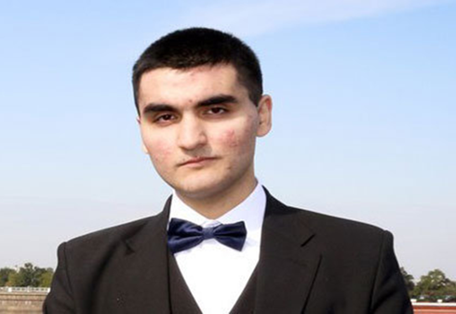 | Alexander Eivazov; a whistle-blower and a former court secretary from St. Petersburg © Private

In December 2016, he resigned from his job. In January 2017, the Deputy Chair of the Oktiabrskiy District Court came to Aleksandr Eivazov’s home, accompanied by police officers, and told him to sign a backdated record of a court session prepared by another court secretary. Aleksandr Eivazov refused to do so. Shortly afterwards, the Investigation Committee opened a criminal case against him, accusing him of “interfering with the course of justice with the use of official position” and “slander with the use of official position” (Article 294 (3), and Article 128 (3), of the Russian Criminal Code). Aleksandr Eivazov was arrested and remanded in custody in August 2017. Amnesty International called for his immediate and unconditional release.
Aleksandr Eivazov’s trial started on 21 June 2018 in the St Peteresburg Kalininskiy District Court. During the course of the trial, the prosecution dropped the charge of “slander with the use of official position”. On 18 July, the court found Aleksandr Eivazov guilty of “interfering with the course of justice with the use of official position” and sentenced him to 22 months’ imprisonment in an open penal colony. Days before the District Court’s judgment, a new law came into force which stipulates that one day in pre-trial detention is equivalent to two days in an open penal colony. This new law meant that Aleksandr Eivazov had already effectively served almost his entire sentence while in pre-trial detention. In Russia, the rate of acquittals in court is so low that prison sentences equal to the time already spent in pre-trial detention are regarded by defence lawyers as positive outcomes almost equivalent to acquittals. Aleksandr Eivazov was released on 21 July 2018. His lawyer lodged an appeal seeking to overturn the conviction and on 21 November the Saint Petersburg City Court acquitted Aleksandr Eivazov.
Lawyers play an extremely important role in defending human rights, especially in a context where the rule of law is weak. In Russia, however, lawyers often face violations of their own rights in spite of the privileges and protections guaranteed by law to those who are licensed advokats (advocates). Those lawyers who do their work diligently and refuse to be diverted from acting in their clients’ best interests are particularly at risk. The harassment they face ranges from threats to physical violence. Some, like Mikhail Benyash, face not only police violence but also fabricated criminal charges.
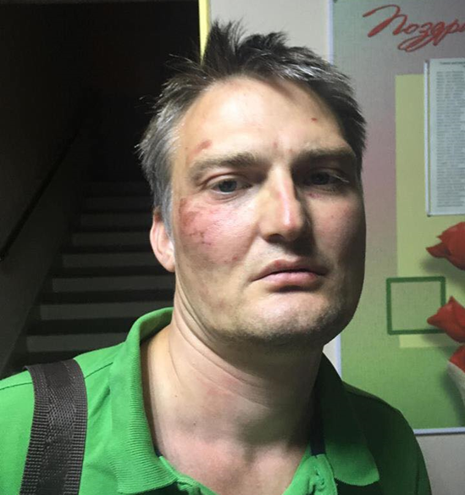 | Mikhail Benyash, a human rights lawyer from Krasnodar Region, after ill-treatment by the police © Private

On 9 September 2018, Mikhail Benyash was stopped by two men as he was travelling to Krasnodar city centre in southern Russia. He was going there to provide legal assistance to people planning to take part in a peaceful rally against pension reform. Police routinely detain activists arbitrarily, and in some cases, as happened in Krasnodar, detain known activists even before a rally takes place. Mikhail Benyash was hoping that the presence of a lawyer would result in fewer detentions and that police would be more likely to refrain from using violence against peaceful protesters.
It later emerged that the two men who approached Mikhail Benyash were plain clothes police officers. Mikhail Benyash described how, without giving any explanation, the two men pushed him into a car, grabbed his phone and repeatedly punched and grabbed him round the throat. They then handcuffed him, threw him face down on the pavement near the car, before dragging him into the city police station, where the beatings and other ill-treatment continued.
A lawyer who came to represent Mikhail Benyash was denied access to his client for seven hours. However, the photos the lawyer took when he did get access clearly show Mikhail Benyash’s injuries and are widely available online. Mikhail Benyash was subsequently taken to a hospital where the medical staff recorded multiple injuries including multiple abrasions and bruises to his face, hands, neck and jaw and bleeding from his left eardrum.
On 11 September 2018, the Leninsky District Court of Krasnodar city found that Mikhail Benyash had violated Article 19.3 of the Russian Code of Administrative Offences (“resisting the police’s legitimate orders”) and sentenced him to 14 days’ administrative detention. The police claimed that Mikhail Benyash got into their car voluntarily and then “provoked a fight, was hitting his head against the car window, and was inflicting injuries on himself”. It was on account of his purported resistance to police and self-injury inside the police car that he was judged to have violated Article 19.3. The court accepted the police’s claims without question, ignored Mikhail Benyash’s allegations of ill-treatment and refused to hear the account of an eyewitness, who was present at the hearing, about the circumstances of Mikhail Benyash’s detention and beating by police.
Mikhail Benyash was due to be released on 23 September. However, just hours before his intended release, he was taken to Krasnodar Temporary Detention Facility (IVS). On 24 September 2018, the Investigation Committee for Krasnodar Region announced in a press release that a criminal case had been opened against Mikhail Benyash under Article 294(1) of the Russian Criminal Code (“obstruction of justice and preliminary investigation”). The lawyer was accused of “violating public order in court” when defending his client on 6 May 2018. The investigators claimed that during the hearing, Mikhail Benyash had “interrupted, gave orders, expressed demands and raised objections against the judge’s decisions”. In the same press release, the Investigation Committee stated that another criminal case, under Article 318 (1) of the Russian Criminal Code (“use of violence against a government official”) had been opened against him. According to the investigation, the arresting officer accused Mikhail Benyash of “beating” and “biting” police officers. Mikhail Benyash was detained for a further 48 hours, and on 28 September the Leninsky District Court in Krasnodar ordered that he be remanded in custody for two months. Amnesty International considered Mikhail Benyash to be a prisoner of conscience targeted for his human rights work and called for his immediate and unconditional release.
On 23 October 2018, following an appeal by his defence team and a request from the Prosecutor’s Office, which found no reason for extending his detention, the Krasnodar Regional Court ordered that Mikhail Benyash be released on bail. In December 2018, the Investigation Committee closed the case against Mikhail Benyash under Article 294(1) due to the absence of elements of a crime but pressed charges against him under Article 318(1) of the Russian Criminal Code. In January 2019, the Krasnodar Leninsky District Court started hearing Mikhail Benyash’ case. At the time of writing, the trial of Mikhail Benyash was ongoing. Amnesty International urges the Russian authorities to drop all the charges against Mikhail Benyash and to conduct an effective, thorough and impartial investigation into the circumstances of his arrest and his allegations of ill-treatment by the police.
- THE USE OF LEGISLATION TO OBSTRUCT AND DISCREDIT HUMAN RIGHTS WORK
“Everyone has the right, individually and in association with others, to solicit, receive and utilize resources for the express purpose of promoting and protecting human rights and fundamental freedoms through peaceful means, in accordance with article 3 of the present Declaration.”
Article 13 of the UN Declaration on Human Rights Defenders

Statements by local and federal officials and politicians that undermine or seek to discredit human rights defenders and their work are not uncommon in Russia. These typically claim or highlight foreign funding and allude to hostile external interests which foreign “paymasters” seek to advance through the organizations they fund. This toxic, government-sponsored narrative receives prominent coverage in the mainstream, government-controlled media and is often accompanied by the so-called “investigation reports” broadcast on national television, with the sole apparent purpose of tarnishing the reputation of these defenders.
In recent years, this has amounted to a smear campaign against frontline human rights organizations and other independent NGOs. A key element of this campaign, and the wider continuing attacks on the rights to freedom of expression and association in Russia, has been the new legislation passed since 2012 and its aggressive application in practice. In a two-pronged attack, the Russian authorities have targeted independent Russian NGOs directly through the “Foreign Agents Law” and sought to cut the foreign funding lifeline that enabled them to operate independently through the law on “Undesirable Foreign Organizations”. While seeking foreign funding is not officially prohibited in Russia, these two laws have effectively made funding by foreign donors toxic to the extent that organizations must either turn such funding down or be prepared to face “consequences” if they dare to accept it.
These laws have drastically reduced the funding available for Russian civil society organizations and, in some cases, put their very existence at risk. They similarly imposed additional, burdensome reporting requirements on them. By undermining public trust in these organizations, these laws drove a wedge between civil society organizations and the general public. The two laws have also served as an informal, but very real, barrier to the ability of NGOs to engage in and maintain meaningful working relationships with the authorities.
The “Foreign Agents Law”, enacted in November 2012, has had a profound effect on civil society in Russia. The law compels Russian NGOs to register as “organizations performing the functions of foreign agents” if they receive foreign funding and engage in vaguely defined “political activities”. The law was amended in May 2014 to give the Ministry of Justice the authority to include NGOs in the register on its own initiative. Shortly after it came into force, hundreds of Russian NGOs faced intrusive unannounced “inspections” by teams of prosecution, tax and other state officials. These were sometimes accompanied by TV crews, leading to reports on national television that sought to cause serious damage to the organizations’ reputations. Many also became embroiled in protracted legal battles to defend their right not to be labelled “foreign agents”. Subsequent amendments to the law purported to streamline its application and give a narrower and more precise definition of “political activity”, and thus soften the “Foreign Agents” law but did not, in fact, substantially change it. On the contrary, new regulations were introduced shortly after, imposing further limitations on “foreign agents”. In November 2017, the scope of the “Foreign Agents” legislation was extended so as to apply to media outlets.
More than 20 NGOs were added to the “foreign agents” register in 2017, 2018 and early 2019 by the Ministry of Justice, which as of March 2019 included a total of 74 NGOs. Although this represents a reduction compared to the 148 “foreign agents” listed in November 2016, the list includes, or has included, virtually all frontline human rights and other prominent Russian NGOs. In addition, dozens of such NGOs have closed down because they were unwilling to accept the toxic label of being a “foreign agent”, while a much smaller number have managed to get themselves removed from the register by declining all foreign funding, often at the cost of considerably scaling down their operations.
Those NGOs that remain on the register face harassment and are at constant risk of reprisals for “not observing” the provisions of the “foreign agents” law. For example, in August 2018, the Ioshkar-Ola City Court fined the prominent local NGO Man and Law 300,000 roubles (around US$4,500) because its Facebook page did not indicate clearly that the NGO is “a foreign agent”, as required by the Law. Members of the NGO later learned that the case against them had been initiated by a member of the Federal Security Service (FSB). In September 2018, the fine was reduced on appeal to 150,000 roubles (around US$2,300). However, this is still a huge amount of money for a regional organization and is the third fine imposed on Man and Law for alleged violations of “foreign agents” law. In April 2019, a court in Moscow fined the movement For Human Rights 300,000 roubles (US$ 4,500) for its refusal to be branded a “foreign agent”. While the NGO was not a recipient of any foreign funding, the authorities claimed that one of its members had bought a train ticket using foreign money and that its leader, Lev Ponomarev, had received foreign money into his personal bank account. This is already the second time the movement For Human Rights has been included into the “foreign agents” register.
Violations of the “foreign agents” law result in large fines, and these are regularly used by the authorities to drive NGOs into effective bankruptcy. For instance, in December 2018 and January 2019, the environmental organization “Ecodefence!” - one of the first NGOs included in the “foreign agents” register - was fined over 2 million roubles (US$ 30,640) for alleged violations of the “foreign agents” law. The organization’s bank accounts were blocked, as the NGO could not pay the fine. Its members have tried unsuccessfully to have the organisation removed from the “foreign agents” list. In May 2019, a total of five criminal cases were opened against the NGOs’ director, Aleksandra Koroleva, in connection with unpaid fines. This has created a dangerous precedent for similar persecution of directors in other organizations. A staff member of the NGO explained to Amnesty International that the organization simply has no funds to pay the fines as they can only use their budget for the purposes assigned in their projects.
“Ecodefence!” is one of the oldest environmental NGOs in Russia. Its successes include effective campaigning against the building of a nuclear power plant in Kaliningrad Region, exposing the dangerous pollution caused by coal mining, and the development of an environmental education curriculum. It is one of dozens of Russian NGOs which have submitted applications against the “foreign agents” law to the European Court of Human Rights (ECtHR).
The “foreign agents” law of 2012 also introduced Article 330.1 into the Criminal Code. It criminalized “malicious evasion of the duties of submitting documents necessary for inclusion of the organization into the foreign agents register”. In 2016, human rights defender Valentina Cherevatenko, leader of the Women of the Don Union, became the first, and so far the only, civil society activist to be charged under this Article. The charges against her were eventually dropped in June 2017. However, this remains a crime in law and a potential risk for human rights defenders and other civil society activists in Russia.

Valentina Cherevatenko, Leader of the Women of the Don Union © Private

In May 2015, a law on “undesirable” foreign organizations was adopted in a move to sever Russian civil society’s links with, and support from, international partners. Under this law, the Office of the Prosecutor General can ban a certain foreign organization (typically, a funding organization) from Russia if it deems that the organization poses a threat to the country’s “constitutional order, defence potential or state security”. The vague nature of this law appears deliberate. From the moment such an organization is banned, any cooperation with it in Russia becomes an administrative offence punishable by a huge fine in the first instance, and a crime punishable by imprisonment thereafter.
Eight foreign organizations were declared “undesirable” in 2017 and 2018 and two in 2019, bringing the total number at the time of writing to 17. These organizations can no longer operate in Russia. Furthermore, any cooperation, or even loose association, with them is prohibited by law.
The UK-based Open Russia Civic Movement and Otkrytaya Rossia (OR) were proclaimed “undesirable” in April 2017. Following this, a growing number of activists of the Russia-based unregistered Otkrytaya Rossiya movement were fined for their alleged cooperation with them. Some have left the country fearing criminal prosecution after being repeatedly fined. In 2019, the authorities intensified their reprisals against Otkrytaya Rossiya activists: at the time of writing, criminal proceedings under Article 284.1 of the Russian Criminal Code (“Carrying out activities of an undesirable organization”) have been opened against five individuals: Anastasia Shevchenko (placed under house arrest), Yana Antonova, Maksim Vernikov, Anton Mikhalchuk and Aleksandr Savelyev.

Anastasia Shevchenko, Coordinator of the Otkrytaya Rossiya movement in Rostov-on-Don © Otkrytaya Rossiya

On 21 January 2019, police raided the homes of six Otkrytaya Rossiya activists in Rostov-on-Don (southern Russia) and Kazan (central Russia). A criminal investigation was opened against Anastasia Shevchenko, the movement’s Coordinator in Rostov-on-Don who had been fined numerous times during 2018 in connection with her work. This is the first-ever criminal case opened under Article 284.1 of the Criminal Code, which criminalizes a repeated alleged violation of the law on “undesirable organizations.” On 23 January, Anastasia Shevchenko was placed under house arrest. A single mother of three at the time, she suffered a personal tragedy exacerbated by her arrest a week later, when her eldest daughter Alina was hospitalized and died of an acute respiratory condition (obstructive bronchitis). The authorities initially dismissed Shevchenko’s request to visit her daughter Alina, who lived in a boarding school for children with special needs, and allowed a visit only hours before her death. Anastasia Shevchenko may face up to six years in prison if convicted. She is a prisoner of conscience, and Amnesty International is campaigning for her immediate and unconditional release.
The law on “undesirable” organizations has also been used to persecute human rights organizations. In September 2017, the prominent human rights NGO SOVA Centre was accused of “distributing” the materials of “undesirable” organizations. Proceedings were opened under the Code of Administrative Violations against the organization and its director, Alexander Verkhovsky. The accusations arose in connection with the SOVA Centre’s website which contained hyperlinks (since removed) to the “undesirable” National Endowment for Democracy and the Soros Foundation, donors to SOVA Centre in previous years. The case was closed in December 2017 after the expiry of the statute of limitations.
In December 2017, a court in St Petersburg fined another NGO, the Centre for Independent Sociological Research (CISR), 50,000 roubles (approximately US$ 859) for exactly the same “offence”; the organization’s website contained information about the activities of the Open Society Institute (OSI) Assistance Foundation and links to Open Society Foundations materials. CISR appealed this decision, and on 14 March 2018 a higher court quashed the earlier decision and ordered a new hearing. The Prosecutor’s Office tried to appeal this decision, unsuccessfully, and on 15 August 2018, Kuibyshevsky District Court in St Petersburg closed the case.
On 10 July 2018, the Andrey Rylkov Foundation, a prominent Russian NGO defending the rights of drug users and working on HIV prevention, was fined for having a hyperlink to an “undesirable organization” on its website. The organization duly submitted a complaint to the European Court of Human Rights (ECtHR).
The Environmental Watch for North Caucasus (EWNC) was similarly fined 80,000 roubles (US$ 1,235) in April 2019 by a court in Maikop, Krasnodar Region, for reposting blogs on environmental issues written by its activists but previously published on the website of the Otkrytaya Rossia . While the court was considering the case, EWNC’s representative Andrey Rudomakha was held up by armed and masked security forces who were conducting a house search at the house rented by one of the NGO’s staff members (the search related to another “undesirable” criminal case, against Otkrytaya Rossia activist Yana Antonova). Andrey Rudomakha appealed the decision but it was upheld by Maikop City Court in June 2019.
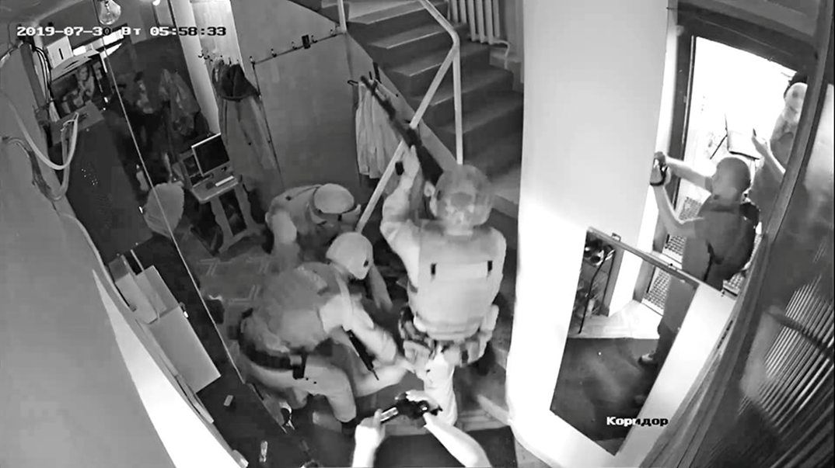 | A search conducted at the house rented by one of the Environmental Watch staff members, 30 July 2019 © A still from CCTV footage

LGBTI organizations, some of which were also labelled “foreign agents”, face additional barriers in their work because of the so-called “propaganda” law. In 2013, following a series of similar local legislative initiatives, a homophobic federal law was adopted that made “propaganda of non-traditional sexual relations among minors” an administrative offence. According to a recent study by the Russian LGBT Network, this law has led to a rise in the number of hate crimes, including assaults, against LGBTI people and increased levels of discrimination.
The “propaganda” law has in practice acted as a form of censorship on any public debate regarding almost anything to do with the rights of LGBTI people. Several LGBTI rights defenders have been fined under this law for staging small public pickets in defence of LGBTI rights and other “offences”, including in some cases nothing more than posts on their social media accounts. For example, in Samara, a young human rights defender, Evdokia Romanova, was fined under the “propaganda” law in 2017 for reposting on her personal social media account links to foreign media publications, including an article in The Guardian, on the same-sex marriage referendum in Ireland and a Buzzfeed article on an exhibition in St Petersburg on Russian LGBTI teenagers.
Many LGBTI activists have also reported the very real negative impact of the “propaganda” law on some of their wider work, including, for instance, projects on HIV/AIDS prevention which the organizations were implementing in close cooperation with medical institutions.
- CONCLUSION AND RECOMMENDATIONS

This brief document features some of the most glaring issues and emblematic cases demonstrating that the Russian authorities are not only failing in their international obligations to protect HRDs but also use a range of means to attack individuals and whole sectors of civil society as reprisals for their work and a way to deter others from engaging in such activities. However, this document is not comprehensive - numerous important cases have not been included here, yet they echo the same general trends. These are not isolated cases but an illustration of deliberate policies and general trends.

The Russian authorities’ treatment of and attitude towards a peaceful, active part of the population is dangerous in that it stifles activism, undermines initiatives and curtails people’s sense of belonging. Human rights defenders bring serious issues involving laws, policies and practices which affect everyone in society to the public fore. They try to find solutions, improve systems and achieve justice for those whose rights are violated. In so doing, they are promoting and protecting human rights for all. It is in the interest of the Russian authorities to stop persecuting these activists, fulfil their human rights obligations under international law and those enshrined in Russia’s own Constitution, get rid of the “besieged fortress” mentality and start working with human rights defenders and civil society organizations as allies for the greater public good.

RECOMMENDATIONS:

To the Russian authorities:

  - Immediately end the persecution of human right defenders in Russia – including harassment, intimidation, physical attacks, arbitrary detention, prosecution, imprisonment and fines;
  - Publicly acknowledge the importance of human rights work and ensure that human rights defenders are able to operate freely;
  - Ensure that all cases of physical attacks, intimidation and threats against human rights defenders are promptly, effectively and impartially investigated and those responsible brought to justice in fair trial proceedings;
  - Develop protection measures in cooperation and consultation with human rights defenders, offer these to HRDs at risk and take positive steps to implement them;
  - Immediately and unconditionally release anyone detained or imprisoned solely for exercising their human rights peacefully and drop any criminal proceedings against them. Take steps to ensure reparations to those whose rights have been violated, including through physical attacks, arbitrary detention and violations of their right to fair trial;
  - Abide by Russia’s international obligations in relation to the rights to freedom of expression, association and peaceful assembly and bring Russia’s legislation into line with international human rights law and standards;
  - Grant approval for the pending visit request of the UN Special Rapporteur on the situation of human rights defenders; invite and enable visits by the CoE Commissioner for Human Rights and relevant PACE Rapporteurs so that they can conduct visits without restrictions on duration or scope and ensure they are allowed to meet with HRDs without hindrance
  - Repeal the laws on “foreign agents”, “undesirable organizations” and “propaganda of non-traditional sexual relations among minors” and provide access to an effective remedy to anyone prosecuted or otherwise reprimanded under these laws;
  - As the first steps, repeal Articles 284.1 and 330.1 of the Russian Criminal Code establishing criminal responsibility in connection with the law on “undesirable organizations” and “foreign agents” law;
  - Ensure unhindered access to resources, including those of foreign donors, to support stable functioning of civil society organizations.

To the EU, EU Members States and likeminded countries:

  - Continue raising the situation of HRDs as well as individual HRD cases with the Russian authorities in bi-lateral and multi-lateral fora: This includes the meetings of EU and member state officials with the Russian Foreign Minister, the Chairman of the Presidential Council for Civil Society and Human Rights, the Russian Human Rights Commissioner and during the EU ambassadors’ regular meetings with the Russian Foreign Minister and regional governors. The EU should also consider how accompanying these meetings with public statements that reaffirm the EU’s support for HRDs could enhance the impact of its closed-door efforts.
  - Through effective burden- and information sharing, ensure trial observation of cases where HRDs are sued or prosecuted solely for their peaceful work, including cases under the Law on “Foreign Agents” and the “Undesirable Organizations” law and cases where NGOs and individual HRDs are fighting smear campaigns;
  - Increase the visibility and impact of trial observation: This could be done by accompanying EU trial observation efforts with public statements, media interviews and social media posts supporting the HRD in question;
  - Establish a protocol outlining responses and possible preventive measures to physical attacks against HRDs: For HRDs facing threats, preventative measures could include raising their cases with regional and federal authorities to avert attacks and supporting/facilitating the emergency relocation of at-risk HRDs and their families.
  - Facilitate flexible visa procedures for HRDs, including by being flexible regarding proof of income requirements (e.g. salary slips), maximum duration of stay restrictions and add-on fees (e.g. travel insurance requirements for HRDs.) Officials should take into account specificities of LGBTI activists (e.g. same-sex partners can be considered family members).
  - Contribute to raising Russian HRDs’ profiles, including by organizing high-level visits to regions, meetings with HRDs that are publicized on social media, when possible.

To the Council of Europe:

  - Ensure that the Council of Europe Programme Office in Moscow supports and gives visibility to HRDs, by meeting and engaging HRDs in their activities; generates awareness on key judgments of the European Court of Human Rights concerning Human Rights Defenders, freedom of association, freedom of assembly and freedom of expression in Russia; and makes public the recommendations of the Commissioner for Human Rights , the Venice Commission and PACE concerning the Russia and HRDs, in line with the Committee of Ministers Recommendation CM/Rec(2018)11 and with the Helsinki Ministerial Decision adopted by the Committee of Ministers on 17 May 2019, on the need to strengthen the protection and promotion of civil society space in Europe .
  - To the Committee of Ministers: As requested by the Committee of Ministers Recommendation CM/Rec(2018)11, pay “ special attention within the Committee of Ministers to the execution of judgments of the European Court of Human Rights concerning human rights defenders and the enabling environment for human rights work, which have yet to be implemented”; and ensure “continuous dialogue and debates on threats to civil society, NHRIs and human rights defenders, in particular to address threats and attacks on human rights defenders and to express concern for the unjustified detention and criminal charges which effectively lead to halting civil society work in Council of Europe member States;”
  - To the PACE: Continue to give visibility and support to the crucial role and legitimacy of the work carried out by HRDs; and address, through its monitoring, the growing limitations to the enabling environment for HRDs in Russia through the various rapporteurships, in particular through the reports of the Monitoring Committee.

Amnesty international
is a global movement
for human rights.
When injustice happens
to one person, it
matters to us all.

Unfair game:
persecution of human rights defenders in russia intensifies
Human rights defenders in Russia have always faced harassment, intimidation, physical attacks and arbitrary arrests for their work. However, in recent years the level and extent of the reprisals they face have increased significantly, to a point where being a human rights defender means risking your reputation, freedom and even your life.

This publication provides a snapshot of the current dire situation through several stories. They illustrate the wide range of violations of the human rights, the same rights which Russia has committed to respect, protect and fulfil. The Russian authorities must acknowledge and address these violations and ensure that human rights defenders are protected and can do their work without fear of persecution.

These are enshrined in the International Covenant on Civil and Political Rights; the International Covenant on Economic, Social and Cultural Rights; the European Convention on Human Rights; and the Declaration on the Right and Responsibility of Individuals, Groups and Organs of Society to Promote and Protect Universally Recognized Human Rights and Fundamental Freedoms (UN General Assembly resolution A/RES/53/144), among other human rights instruments.
See EWNC, ‘Napadenie na aktivistov Ecovakhty: Podrobnosti i versii’ (Attack on Ecowatch activists: Details and possible reasons), 29 December 2017, www.ewnc.org/node/24972. Also see, ‘Andrey Rudomakha svyazal napadenie s ekologicheskoi deyatelnostju’ (Andrey Rudomakha thinks the attack is connected with his environmental activities), 29 December 2017, https://www.kavkaz-uzel.eu/articles/314481/
Article 161 (2) paras “a”, ”г”of the Russian Criminal Code.
Article 162(4) para “в“ of the Russian Criminal Code.
Article 277 of the Russian Criminal Code
See EWNC, ‘Lideram Ecologicheskoi Vakhty po Severnomu Kavkazu postupili ugrozy s predlozhenijem “uekhat”’, (Leaders of Environmental Watch for North Caucasus received threats with offers to “leave”), 11 January 2018, www.ewnc.org/node/25180
See Presidential Council for Human Rights, ‘Sledstvie udovletvorilo khodataistvo o primenenii mer gosudarstvennoi zaschity k Andreiu Rudomakhe’ (Investigation upheld request to apply state protection measures to Andrey Rudomakha), 5 March 2018, http://www.president-sovet.ru/presscenter/news/read/4478/
See EWNC, ‘88 tysjach grazhdan trebyjut rassledovat napadenije na Andreia Rudomakhu I vozmozhnuju prichastnost k prestupleniju sotrudnikov FSB’ (88 thousand people demand investigation of the attack on Andrey Rudomakha and possible complicity of FSB officers), 11 January 2018, www.ewnc.org/node/25175
See Dinar Idrisov’s account on OVD-Info, ‘Metodichno bili po golove, preimuschestvenno nogami’ (The were methodically beating my head, kicking it most of the time), 29 January 2018, https://ovdinfo.org/stories/2018/01/29/metodichno-bili-po-golove-preimushchestvenno-nogami Radio Svoboda, ‘Pravozaschitnika Dinara Idrisova izbili na aktsii 28 janvarija v Peterburge’ (Human rights defender Dinar Indrisov was beaten up during a public action in St Petersburg), 29 January 2018, www.svoboda.org/a/29004611.html
See Novaya Gazeta, ‘Desiat minut v klasse vospitatelnoi raboty’ (Ten minutes in a morale building class), 20 July 2018, https://www.novayagazeta.ru/articles/2018/07/20/77222-10-minut-v-klasse-vospitatelnoy-raboty?utm_source=push
An official body tasked with investigating serious and especially serious crimes.
See Amnesty International, Russia: Lawyer covering torture case flees country after threats, News, 23 July 2018, https://www.amnesty.org/en/latest/news/2018/07/russia-lawyer-covering-torture-case-flees-country-after-threats/
See Interfax, ‘Genprokuratura poprosila FSB esche raz proverit zayavlenie advokata Biriukovoi o goszaschite’ (Prosecutor General’s Office requested FSB to once again check lawyer Biryukova’s appeal for state protection), 10 October 2018, https://www.interfax.ru/russia/632748 ; Interfax, ‘Advokat izbitogo v yaroslavskoi kolonii zakliuchennogo poluchila goszaschitu’ (Lawyer of an inmate beaten up in Yaroslavl penal colony got state protection), 13 November 2018, https://www.interfax.ru/russia/637707
See Amnesty International, ‘Russia must track down masked assailants after insidious homophobic attack’, News, 4 November 2013, www.amnesty.org/en/latest/news/2013/11/russia-must-track-down-masked-assailants-after-insidious-homophobic-attack/
See Russian LGBT Network, ‘LGBT activisty streliajut sami v sebja, chtoby privlech vnimanie SMI: Kak rassledujutsja prestuplenija nenavisti v Rossii’ (LGBT activists shoot themselves to attract media attention: How hate crimes are investigated in Russia), https://lgbtnet.org/ru/newseng/lgbt-aktivisty-strelyayut-sami-v-sebya-chtoby-privlech-vnimanie-smi-kak-rassleduyutsya
See Russian LGBT Network, ‘Soversheno napadenije na office murmanskoi LGBT-organizatsii “Maksimum”’ (Office of Murmansk LGBT organization Maximum was attacked), https://lgbtnet.org/ru/content/soversheno-napadenie-na-ofis-murmanskoy-lgbt-organizacii-maksimum
For instance, see Amnesty International, ‘Russia: Activist Attacked and Threatened’, Urgent Action, 17 December 2014, (Index number: EUR 46/055/2014 www.amnesty.org/en/documents/eur46/055/2014/en/ ’Russia: Attack on Rights Group in Chechnya: Investigate Mob Violence, Protect Activists’, Joint statement by Amnesty International, Human Rights Watch and Frontline Defenders, 3 June 2015, (Index number: EUR 46/1804/2015), www.amnesty.org/en/documents/eur46/1804/2015/en/ and ’Russia: Brazen assault on journalists and human rights defenders in North Caucasus illustrates official failures’, News, 10 March 2016, www.amnesty.org/en/latest/news/2016/03/russia-brazen-assault-on-journalists-and-human-rights-defenders-in-north-caucasus-illustrates-official-failures/
See, Novaya Gazeta, ‘SK nachal proverku po publichnomu zajavleniju Kadyrova v otnoshenii “nekoego Kaliapina”’ (Investigation Committee started an examination following Kadyrov’s public statement in relation to “some Kaliapin”), 18 December 2014, www.novayagazeta.ru/news/2014/12/18/108780-sk-nachal-proverku-po-publichnomu-zayavleniyu-kadyrova-v-otnoshenii-171-nekoego-kalyapina-187
See, Novaya Gazeta, ‘Posle mnogotysjachnogo mitinga v Groznom za pravozaschitnikami iz gruppy Igorya Kalyapina nachalas pogonja’ (After thousands-strong rally in Grozny human rights defenders from Igor Kalyapin’s group were chased), 13 December 2014, www.novayagazeta.ru/news/2014/12/13/108655-posle-mnogotysyachnogo-mitinga-v-groznom-za-pravozaschitnikami-iz-gruppy-igorya-kalyapina-nachalas-pogonya
See Amnesty International, ‘Russian Federation: Joint Mobile Group Office Ransacked by Mob’, Urgent Action, 3 June 2015, (Index number: EUR 46/1802/2015), www.amnesty.org/en/documents/eur46/1802/2015/en/
See Amnesty International, ‘Russia: Brazen assault on journalists and human rights defenders in North Caucasus illustrates official failures’, News, 10 March 2016, available at: www.amnesty.org/en/latest/news/2016/03/russia-brazen-assault-on-journalists-and-human-rights-defenders-in-north-caucasus-illustrates-official-failures/ and ‘Russia: There must be no more impunity for attacks on human rights defenders and journalists’, Public Statement, 10 March 2016, (Index number: EUR 46/3609/2016), www.amnesty.org/en/documents/eur46/3609/2016/en/
See Mediazona, ‘“Lozhis, ubju!” Press-tur v Chechnju’ (“Down on the ground, or I kill you!” Press tour to Chechnya), 15 March 2016, https://zona.media/article/2016/03/15/tour-95
Videos of the attack are available at www.youtube.com/watch?v=7RgU7qMAz8M
See RIA Novosti, ‘Peskov: Napadenie na chlena SPCH v Chechne nepriemlimo’ (Peskov: Attack on the member of the Presidential Council for Human Rights in Chechnya is unacceptable), 17 March 2016, https://ria.ru/society/20160317/1391529995.html
See Mediazona, 1 March 2017, https://zona.media/number/2017/01/03/kalyapin and Komitet Protiv Pytok (Committee Against Torture), ‘Deistvija neizvestnykh byli napravleny na zaschitu glavy Chechenskoi Respubliki’ (Actions of unidentified people were in defence of the Head of the Chechen Republic), 12 May 20017, www.pytkam.net/press-centr.novosti/4564 ; Igor Kalyapin told Amnesty International that he had received at least eight refusals.
Immediately after the attack, a criminal case was initiated under Article 213 (2), of the Russian Criminal Code (“Conspiracy to perform an act of hooliganism by a group of people”) and Article 167 (2), (“Intentional destruction or damage to property of citizens by a publicly dangerous method”). On 12 March, one more case was opened under Article 162 (2), (“Robbery by a group of people with use of weapons”) and on 30 March, a case was opened under Article 144 (3), (”Prevention of lawful professional journalistic activity with use of violence against journalists and damage or destruction of their property”). The cases were then combined into one file.
See Amnesty International, ‘Russian Federation: Journalist Threatened by Chechen Official’, Urgent Action, 9 January 2017, (Index number: EUR 46/5442/2017), www.amnesty.org/en/documents/eur46/5442/2017/en/
See Grozny Inform, ‘Zajavlenie Predsedatelia Parlamenta ChR Magomeda Daudova v svjazi s vkliucheniem Glavy CHR Ramzana Kadyrova v “spisok Magnitskogo”’ (Statement by the Chairperson of the Parliament of the Chechen Republic Magomed Daudov in connection with includion of the Head of Chechnya Ramzan Kadyrov into “Magnitski list”), 25 December 2017, www.grozny-inform.ru/news/politic/91807/
See Meduza, ‘V Makhachkale izbili glavu dagestanskogo otdeleniya Memoriala’ (Head of Dagestan Memorial was beaten up in Makhachkala), 28 March 2018, https://meduza.io/news/2018/03/28/v-mahachkale-izbili-glavu-dagestanskogo-otdeleniya-memoriala
See: https://www.facebook.com/lgbtnet/videos/vb.106592406129121/386894168804255/?type=2&theater
On file with Amnesty International
See, Memorial, ‘Vystuplenije advokata Petra Zaikina v preniyakh na processe Ruslana Kutaeva’ (Lawyer Petr Zaikin’s speech during oral statements of the parties at Ruslan Kutaev’s trial), memohrc.org/ru/news/vystuplenie-advokata-petra-zaikina-v-preniyah-na-processe-ruslana-kutaeva
See Amnesty International, ‘Activist sentenced on fabricated charges’, Urgent Action, 11 July 2014, (Index number: EUR 46/043/2014), www.amnesty.org/download/Documents/8000/eur460432014en.pdf
See Kavkazskii Uzel, ‘Zhalaudi Geriev’, 5 December 2017, www.kavkaz-uzel.eu/articles/292636/
For a full description of the case and accounts of the persecution, see Human Rights Centre Memorial, https://memohrc.org/ru/defendants/titiev-oyub-salmanovich
For details of Oyub Titiev’s account of the event, see, for example, his video interview with the Current Time correspondent, www.currenttime.tv/a/29534005.html
See, for example, translation of Kadyrov’s statement, broadcast on 17 January by the Chechen TV channel GHGTRK, “Grozny”, which he made at a meeting with law enforcement officers, https://memohrc.org/ru/news_old/chechnya-v-syuzhete-na-chgtrk-groznyy-ramzan-kadyrov-dal-chetko-ponyat-za-chto-posadili#sdfootnote1sym The video with the news feature is available at www.youtube.com/watch?v=BPHnaecqgso&t=249s
See, for example, news feature of 12 January 2018, www.youtube.com/watch?v=cfcGRBERy64
See Amnesty International, “Russia: Titiev's parole a welcome step but not justice”, News, 10 June 2019, https://www.amnesty.org/en/latest/news/2019/06/russia-titievs-parole-a-welcome-step-but-not-justice/
See Amnesty International, ‘Russian Federation: Human rights defender detained in Chechnya: Oyub Titiev’, Urgent Action, 10 January 2018, (Index number: EUR 46/7702/2018), www.amnesty.org/en/documents/eur46/7702/2018/en/ and ‘Russia: Authorities must release human rights activist held on baseless accusations’, News, 25 January 2018, www.amnesty.org/en/latest/news/2018/01/russia-authorities-must-release-human-rights-activist-held-on-baseless-accusations/
See, Human Rights Centre Memorial, Nagavkin Igor Borisovich, https://memohrc.org/en/node/7145
Amnesty International, ‘Russia: The bravest World Cup team you’ve never heard of’, News ,7 June 2018, www.amnesty.org/en/latest/news/2018/06/russia-the-bravest-world-cup-team-youve-never-heard-of/ ; Igor Nagavkin, Feature, www.amnesty.org/en/latest/campaigns/2018/06/igor-nagavkin-human-rights-defender-in-russia/ and ‘Pravozaschitnik Igor Nagavkin na svobode posle dvukh let v SIZO’ (Human rights defender Igor Nagavkin is released after two years on remand), Feature, 19 November 2018, https://amnesty.org.ru/ru/2018-11-19-russia/
Amnesty International, ‘Whistle-blower faces two more months in jail’, Urgent Action, 16 February 2018, (Index number: EUR 46/7911/2018), www.amnesty.org/download/Documents/EUR4679112018ENGLISH.pdf
Amnesty International, ‘Whistle-blower detained on spurious charges’, Urgent Action, 3 October 2017, (AI Index number EUR 46/7200/2017), www.amnesty.org/en/documents/eur46/7200/2017/en/
Amnesty International, ‘Russian court whistle-blower released’, Urgent Action, 26 July 2018, (Index number: EUR 46/8831/2018), www.amnesty.org/en/documents/eur46/8831/2018/en / and ‘Byvshiy uznik sovesti Aleksandr Eivazov polnostiu opravdan’ (Former prisoner of conscience Aleksandr Eivazov is fully acquitted), Press Release, 21 November 2018, https://amnesty.org.ru/ru/2018-11-21-russia/
For more on the legal framework regulating the lawyers’ profession in Russia, see Amnesty International, Confronting the circle of injustice: Threats and pressure faced by lawyers in the North Caucasus, 2013, (Index number: EUR 46/003/2013), www.amnesty.org/en/documents/eur46/003/2013/en/
See Radio Svoboda, ‘V Krasnodare zaderzhali I izbili advokata Mikhaila Benyasha’ (Lawyer Mikhail Benyash is detained and beaten up in Krasnodar), 10 September 2018, www.svoboda.org/a/29481491.html
See the description of Mikhail Benyash’s detention in his own words, OVD-Info, ‘Mikhail Benyash: Planiroval pod’ekhat k zaderzhannym. Pri advokatakh biut chiut menshe’ (Mikhail Benyash: I was planning to get to the detained. They beat a bit less when a lawyer is present), 11 September 2018, https://ovdinfo.org/stories/2018/09/11/mihail-benyash-planiroval-podehat-k-zaderzhannym-pri-advokatah-byut-chut-menshe
See Investigation Directorate of the Investigation Committee of the Russian Federation for Krasnodar region, ‘V Krasnodare advokat podozrevaetsya v primenenii nasilia v otnoshenii sotrudnikov politisii’ (A lawyer in Krasnodar is suspected of using force against a police officer), 24 September 2018, http://kuban.sledcom.ru/news/item/1257746/
Amnesty International, ‘Lawyer assaulted and arbitrarily detained’, Urgent Action, 12 September 2018, (Index number: EUR 46/9069/2018), www.amnesty.org/en/documents/eur46/9069/2018/en/
See also Articles 6-9 of the UN Declaration on Human Rights Defenders (GA Res A/RES/53/144), https://documents-dds-ny.un.org/doc/UNDOC/GEN/N99/770/89/PDF/N9977089.pdf?OpenElement
For an illustrative overview and examples of the use of mainstream government-controlled media to smear human rights activists, see a collection of materials by the Tsentr operativnogo reagirovaniya po zaschite pravozaschitnikov (Centre for Prompt Response to Protect Human Rights Defenders), http://sos-hrd.org/node/1732#.WxgIdO4vzIU http://sos-hrd.org/node/1735#.WxgIru4vzIU ; http://sos-hrd.org/node/1720#.WxgI6e4vzIU ; http://sos-hrd.org/node/1681#.WxgJVe4vzIU ; http://sos-hrd.org/node/1650#.WxgJle4vzIU ; http://sos-hrd.org/node/1639#.WxgJ9u4vzIU ; http://sos-hrd.org/node/1618#.WxgKUO4vzIU ; http://sos-hrd.org/node/1617#.WxgKb-4vzIU ; http://sos-hrd.org/node/1609#.WxgKje4vzIU ; and http://sos-hrd.org/node/1587#.WxgLQ-4vzIU For one of the latest examples see, Mediazona ‘S’emochnaja gruppa NTV presleduet advokata po “pensenskomu delu” I dvukh peterburgskikh pravozaschitnits’ (NTV film crew chase a lawyer in “Penza case” and two human rights defenders from St Petersburg),15 April 2018, zona.media/news/2018/04/15/ntv and an overview of the latest research on NGOs in media by Cogita!ru, ‘NKO v media’ (NGO in media), www.cogita.ru/nko/issledovaniya-nko/nko-v-media
Federal law №121-FZ of 20 July 2012 ‘O vnesenii izmenenii v otdelnye zakonodatelnye akty Rossiiskoi Federatsii v chasti uregulirovanija deiatelnosti nekoomercheskikh organizatsii, vypolniayuschikh funktsii inostrannykh agentov’ (“On amendments to certain acts of legislation of the Russian Federation regarding regulation of the activity of non-commercial organizations performing the functions of foreign agents”), “Rossiiskaya Gazeta” on 23 July 2012, https://rg.ru/2012/07/23/nko-dok.html . For subsequent changes to the law go to: http://www.consultant.ru/document/cons_doc_LAW_132900/
Federal Law № 129-FZ of 23 May 2015 “O vnesenii Izmenenii v otdelnye zakonodatelnye akty Rossiiskoi Federatsii” (“On amendments to certain acts of legislation of the Russian Federation”), Rossiiskaya Gazeta” on 26 May 2015, https://rg.ru/2015/05/26/fz129-dok.html
See Amnesty International, ‘Russia stepping up its onslaught on freedom of association’, Public Statement, 4 August 2015, (Index number: EUR 46/2223/2015), www.amnesty.org/en/documents/eur46/2223/2015/en/
For more information, see Amnesty International, Agents of the People. Four Years of “foreign agents” law in Russia: consequences for the society, 18 November 2016, (Index number: EUR 46/5147/2016), www.amnesty.org/en/documents/eur46/5147/2016/en/
See Agents of the People – Four Years of “Foreign Agents” Law in Russia: Consequences for the Society, 18 November 2016, (Index number: EUR 46/5147/2016), www.amnesty.org/en/documents/eur46/5147/2016/en/ and Civil Rights Defenders’ report Never Give Up: Russian Human Rights Defenders Keep Swimming under the Ice, https://crd.org/2018/03/12/never-give-up-russian-human-rights-defenders-keep-swimming-under-the-ice/
See, for instance, the film Yadovityi eksport (Poisonous export) by Olga Skabeeva for the Spetsialnyi Korrespondent (Special Correspondent) programme on the Rossija 1 TV channel, www.youtube.com/watch?v=xHgZd05QIys
They have also engaged in in legal battles with TV channels to try to clear their names. See, for instance, regarding a civil suit brought by the environmental NGO Planeta Nadezhd [Planet of Hopes] against VGTRK, RBK ‘Na VGTRK podali v sud za obvinenie v shpionazhe’(VGTRK is sued for accusations in espionage), 26 February 2016, www.rbc.ru/rbcfreenews/56d02f4d9a7947342a64210d and Interfax, ‘Isk NKO “Planeta Nadezhd” k VGTRK iz-za obvineni v promyshlennom shpionazhe otklonili’ [Civil suit of NGO Planeta Nadezhd against VGTRK for accusations of industrial espionage is rejected], 15 August 2016, http://www.interfax.ru/russia/523617
See, for example, Federal law of 19 July 2018 N 203-FZ “On amendments to Article 18.1 of the Federal Law “On custody of suspects and accused of crimes” and Federal Law “On public control to guarantee human rights of the detainees and assistance to detainees”, http://www.consultant.ru/cons/cgi/online.cgi?req=doc&base=LAW&n=302851&fld=134&dst=100008,0&rnd=0.3539493361774091#008217504345266202 ; Law “On anti-corruption expertise of legislation and draft legislation 172-FZ, of 17 July 2009 as amended on 11 November 2018, http://www.consultant.ru/document/cons_doc_LAW_89553/
Federal law of 25 November 2017 N 327-FZ “On amendments to Articles 10.4 and 15.3 of the Federal law “On information, information technologies and on protection of the information” and Article 6 of the Russian Federation law “On mass media” “, https://rg.ru/2017/11/25/fz327-site-dok.html
See Ministry of Justice of the Russian Federation, list of “foreign agents”, http://unro.minjust.ru/NKOForeignAgent.aspx (accessed 20 March 2019).
See Amnesty International, Agents of the People. Four Years of “foreign agents” law in Russia: consequences for the society, 18 November 2016, (Index number: EUR 46/5147/2016, www.amnesty.org/en/documents/eur46/5147/2016/en/
See: ‘Kto na samom dele hochet oshtrafovat organizatsiu Chelovek I Zakon za otsutstvie markirovki “inostrannogo agenta”?’ (Who really wants to have Man and Law NGO fined for absence of a “foreign agent” marking?), 12 July 2018, http://manandlaw.info/2018/07/12/%D0%BA%D1%82%D0%BE-%D0%BD%D0%B0-%D1%81%D0%B0%D0%BC%D0%BE%D0%BC-%D0%B4%D0%B5%D0%BB%D0%B5-%D1%85%D0%BE%D1%87%D0%B5%D1%82-%D0%BE%D1%88%D1%82%D1%80%D0%B0%D1%84%D0%BE%D0%B2%D0%B0%D1%82%D1%8C-%D0%BE%D1%80 /
See, Novaya Gazeta, ‘Dvizehnie Za Prava Cheloveka oshtrafovali na 300 tysyach rublei za otkaz prisnat sebja inoagentom’ (For Human Rights movement is fined 300,000 rubles for refusal to recognize themselves as a foreign agent), 24 April 2019, https://www.novayagazeta.ru/news/2019/04/24/151179-dvizhenie-za-prava-cheloveka-oshtrafovali-na-300-tysyach-rubley-za-otkaz-priznat-sebya-inoagentom
See ‘Rossijskie vlasti usilivajut davlenie na nezavisimykh ekologov’ (Russian authorities are putting up pressure on independent environmentalists), 18 February 2019, https://ecodefense.ru/2019/02/18/fines/
These applications have been combined by the Court into two cases and communicated to the Russian Federation, decision on these pending at the time of writing. Ecodefence and Others vs Russia, no. 9988/13 https://hudoc.echr.coe.int/eng#{%22itemid%22:[%22001-173049%22]}. On 7 September 2018, the ECtHR also communicated to the Russian authorities the application by environmental rights defender Andrey Rudomakha from the NGO Environmental Watch for the North Caucasus; it concerned a fine of 100,000 rubles (approximately US$1,500) was imposed on him in April 2017 for posting an obituary on his NGO’s Facebook page without marking the post, as the law requires, it was written by a “foreign agent”.
For an analysis of this article pointing out that the crime of “malicious evasion” simply cannot be committed see, Zakon.ru, Sergei Golubok ‘Ugolovnyi kodeks Rossii kak loskutnoe odeyalo. Kommentarii k novoi statie 330.1’ (Russian Criminal Code as a patchwork. Comment to new Article 330.1), https://zakon.ru/blog/2016/10/31/ugolovnyj_kodeks_rossii_kak_loskutnoe_odeyalo_kommentarij_k_novoj_state_3301
See Amnesty International, ‘Russia: Move to outlaw “undesirable” foreign organizations suffocates human rights’, News, 8 July 2015, www.amnesty.org/en/latest/news/2015/07/russia-move-to-outlaw-undesirable-foreign-organizations/
See Ministry of Justice of the Russian Federation, list of “undesirable organizations, http://minjust.ru/ru/activity/nko/unwanted ,accessed 18 July 2019.
See Meduza, ‘Zamestitel predsedatelia “Otkrytoi Rossii” Dmitry Semenov uehal v Litvu’ (Otkrytaya Rossia Deputy Chair left for Lithuania), 6 June 2018, https://meduza.io/news/2018/06/06/zamestitel-predsedatelya-otkrytoy-rossii-dmitriy-semenov-uehal-v-litvu
See, Amnesty International, Russia: First criminal case under “undesirable organizations” law marks a new level of repression, 21 January 2019, https://www.amnesty.org/en/latest/news/2019/01/russia-the-first-criminal-case-under-the-undesirable-organizations-law-marks-a-new-level-of-repression/
See Sova Centre, ‘Dela protiv Centra “Sova” I ego direktora prekrascheny za istecheniem srokov davnocti’ (Cases against Sova Centre and its Director are closed because the statute of limitation expired), www.sova-center.ru/about-us/nashi-slozhnosti/announcement/2017/12/d38562/
The organization was fined 50,000 roubles in November 2017 for having a hyperlink to the Open Society website which had been placed there six years prior to the “undesirable law” coming into force. See ‘FAR oshtrafovan na 50,000 rublei za giperssylu na sait fonda ‘Otkrytoe onschestvo’, razmeschennyiu shest let nazad’ (FAR is fined 50,000 roubles for a hyperlink to Open Society website uploaded six years ago), http://rylkov-fond.org/blog/novosti/shtraf/
See EWNC ‘Ekovakhtu oshtrafovali na 80 tysjach rublei za reposty na ekologicheskie publikatsie ee aktivistov na blogovoi platfrome saita “Otkrytaia Rossija” (Ekowatch is fined 80 thousand roubles for reposts of its activists’ posts on environmental issues previously published on the Open Russia blog platform), 19 April 2019, http://ewnc.org/node/26653
See, EWNC, ‘ Pod predlogom borby s “Otkrytoi Rossiei” krasnodarskoe FSB reshilo blokirovat deyatelnost Ekologicheskoi Vakhty’ (Under pretext of fight against Open Russia Krasnodar FSB decided to block Environmental Watch’ activities), 9 April 2019, http://ewnc.org/node/26610
See, EWNC, ‘Rassmotrenie dela protiv Ekologicheskoi vakhty proshlo v sisteme “telefonnogo pravosudija” (Hearing of a case against Environmental Watch was done in the system of "telephone justice”, 12 June 2019, http://ewnc.org/node/26925
See Rossiiskaia Gazeta, Federal Law of 29 June 2013, N 135-FZ «On amendment to Article 5 of the Federal Law ‘On protection of children from information causing harm to their health and development’ and certain legislation of the Russian federation in order to protect children from information promoting rejection of traditional family values”, https://rg.ru/2013/06/30/deti-site-dok.html. The law introduced Article 6.21 “Propaganda of non-traditional sexual relations among minors” to the Russian Code of Administrative Offences
See Russian LGBT Network, ‘Monitoring diskriminatsii I nasilija na osnovanii seksualnoi orientatsii I gendernoi identichnosti v Rossii v 2016-2017 godah’ (Monitoring of discrimination and violence on the grounds of sexual orientation and gender identity in Russia in 2016-2107), https://lgbtnet.org/sites/default/files/diskriminatsia_web.pdf
See Amnesty International, ‘Russia: Homophobic legislation used to persecute activist who shared LGBTI articles on Facebook’, News, 18 October 2017, www.amnesty.org/en/latest/news/2017/10/russia-homophobic-legislation-used-to-persecute-activist-who-shared-lgbti-articles-on-facebook/

