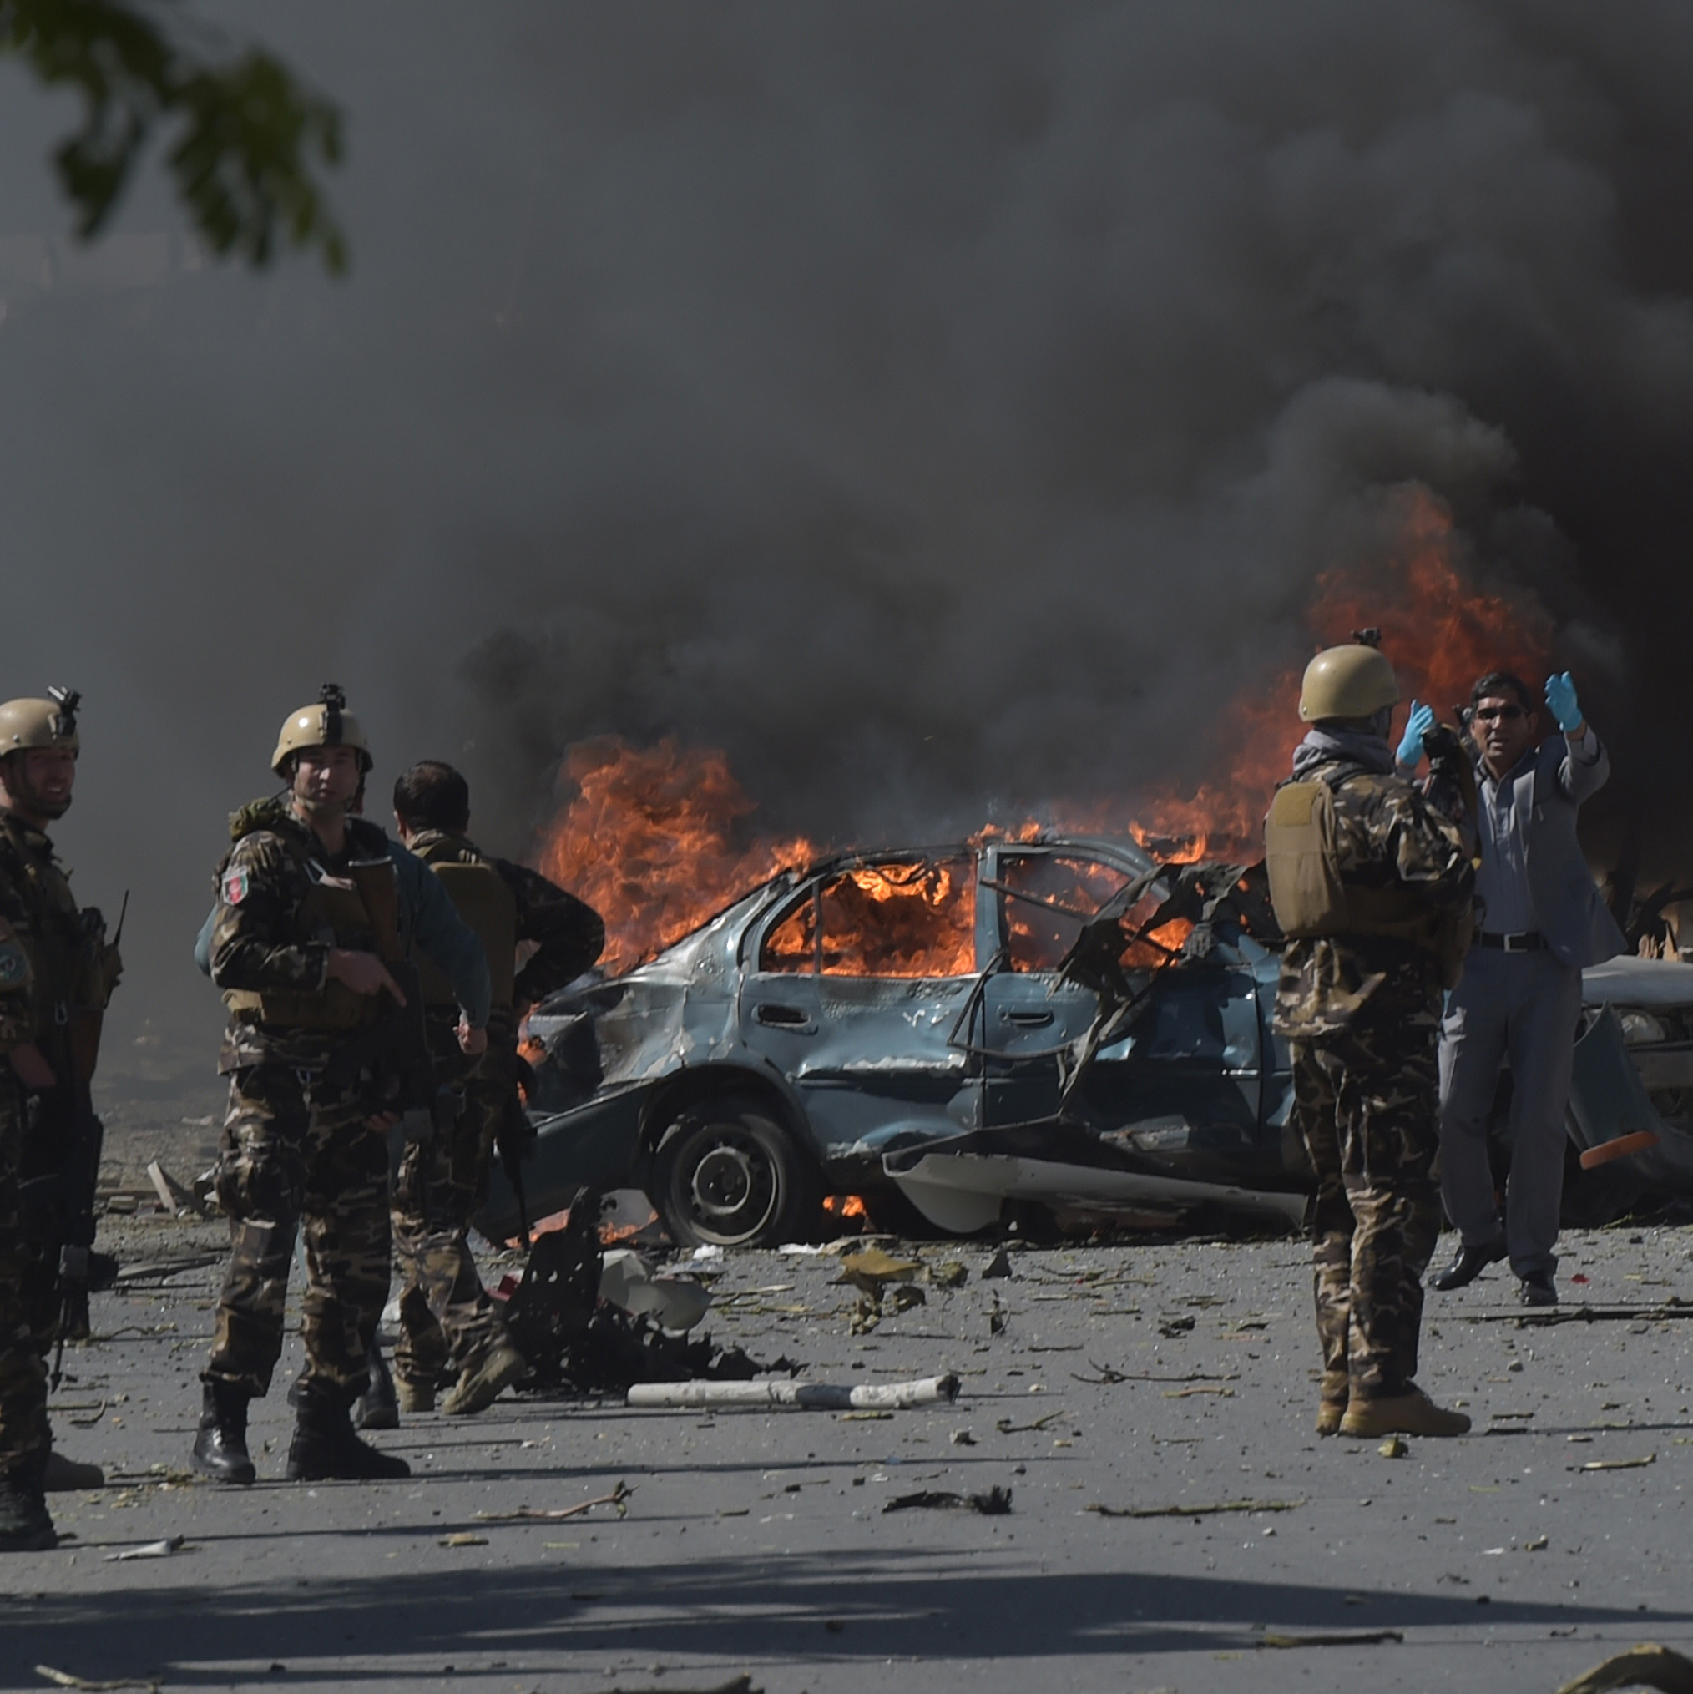
Forced back to danger
Asylum-seekers returned from Europe to AFghanistan

Amnesty International is a global movement of more
than 7 million people who campaign for a world
where human rights are enjoyed by all.
Our vision is for every person to enjoy all the rights
enshrined in the Universal Declaration of Human Rights
and other international human rights standards.
We are independent of any government, political
ideology, economic interest or religion and are funded
mainly by our membership and public donations.

Executive summary
“I’m so afraid I can’t even bring my children to their father’s grave.”
Sadeqa, a woman returned to Afghanistan by Norway with her family in mid-2016

In 2015, Sadeqa’s* husband Hadi was kidnapped in Afghanistan by a group opposed to his work. The family paid a ransom to secure his release, but he was badly beaten and could not speak for days. After he recovered, Sadeqa, Hadi and other family members – including an infant – fled Afghanistan in fear for their lives. After an arduous and dangerous journey of several months, they arrived in Norway where the family lodged an application for international protection, which was eventually refused.
The Norwegian authorities then presented the family with two options: they could be forcibly returned to Afghanistan after being detained for a period of time, or “accept” to go home in a so-called “Assisted Voluntary Return” process, thereby avoiding detention and receiving the equivalent of approximately EUR 10,700. Sadeqa told Amnesty International researchers: “So we agreed to a return and decided to start from scratch again – we had no choice.”
They arrived in Afghanistan in mid-2016. Hadi started in a new line of work, and tried to keep a low profile. But a few months after returning from Norway, he disappeared. A few days later, Sadeqa said she discovered that her husband had been killed, and she is certain that the responsibility lies with the people who had previously kidnapped him. She told Amnesty International researchers that she and the rest of her family remain in hiding in Afghanistan, trapped in their house, and are too afraid to even visit Hadi’s grave.
Sadeqa is one of thousands of Afghans who have been returned from Europe to Afghanistan in the last two years. These returns are taking place despite evidence that people returned to Afghanistan face a real risk of serious human rights violations. This report examines the legality of returns to Afghanistan. It looks at the security and human rights situation in the country and at the experiences of some of those who, like Sadeqa, have been returned by European countries. It contrasts data on the numbers of people being returned from Europe with information on conflict-related casualties and other dangers in Afghanistan, raising a number of questions about the decision-making processes of some European authorities.
To conduct research for this report, Amnesty International researchers travelled to Afghanistan in May 2017 and spoke with 18 women, men and children who had recently been deported from Europe. Researchers also carried out extensive reviews of expert reports on the security and human rights situation across Afghanistan as well as interviews in Afghanistan with local and international civil society organizations, lawyers, academics, the International Organization for Migration (IOM), the United Nations Refugee Agency (UNHCR), and the Afghan Ministry for Refugees and Repatriation. Researchers also met with UNHCR staff at the headquarters in Geneva.
***

Afghanistan is currently gripped by a non-international armed conflict between what are known as “Anti-Government Elements” and Pro-Government Forces. Among the Anti-Government Elements are the Taliban and the group calling itself the Islamic State, but more than 20 armed groups are operating inside the country. UN expert reports and other sources provide evidence that the conflict in Afghanistan and the impact on civilians have gotten worse in the last two years. The United Nations Assistance Mission in Afghanistan (UNAMA) reported that 2016 was the deadliest year on record for civilians in Afghanistan, with 11,418 people killed or injured. The UN body stated:
“In 2016, conflict-related insecurity and violence inflicted severe harm on civilians, especially women and children. The intensification of armed clashes between Pro-Government Forces and Anti-Government Elements over territorial gains and losses resulted in record levels of civilian harm, including the highest number of child casualties and levels of internal displacement documented since 2009.”
The deterioration in the security situation witnessed in 2016 has persisted into 2017. The UN recorded more than 16,290 security-related incidents in the first eight months of 2017 alone. In June 2017, the UN Secretary-General characterized the situation in Afghanistan as “intensively volatile” and the European Civil Protection and Humanitarian Aid Operations (ECHO) stated that the situation had “reverted to an increasingly acute humanitarian crisis.”
Between 1 January and 30 June 2017, UNAMA documented 5,243 civilian casualties (1,662 deaths and 3,581 injured). The majority of these deaths and injuries resulted from the use of Improved Explosive Devices by Anti-Government Elements in civilian-populated areas – particularly suicide bombs and pressure-plate devices. UNAMA has stated that in the first half of 2017, it documented more civilian deaths and injuries from suicide and complex attacks than in any previous six month period since the UN agency began systematic documentation of civilian casualties in 2009.
In terms of civilian casualties, Kabul is the most dangerous province in Afghanistan. However, a review of the 10 provinces with the highest numbers of civilian casualties in 2016 shows that conflict took place country-wide, with provinces in the North, South, East, West and central areas all affected. The conflict is volatile and involves multiple groups that are constantly seeking to gain or regain territory, and whose actions can be unpredictable. Statements by UNAMA and the UN Secretary-General, as well as US government authorities, international NGOs and parts of the Afghan government all underscore the extent to which people are at risk across the country.
Beyond the threat of serious harm to all Afghans as a result of the ongoing conflict, many people in the country are also at particular risk of persecution – defined in European Union (EU) and international law as “severe violations of basic human rights” on the basis of a person’s race, religion, nationality, membership in a particular social group or political opinion. Persecution is not a localized threat. This serious human rights violation takes place across the country, regardless of whether the area is under the effective control of Pro-Government Forces or Anti-Government Elements. In areas under the control of the government, State agents routinely perpetrate human rights violations. Pro-government armed groups are responsible for abuses such as deliberate killings, assault, extortion and intimidation. In regions in which Anti-Government Elements are in control, human rights violations are widespread. These include extrajudicial executions, torture and ill-treatment, as well as denials of the rights to free movement, freedom of expression, political participation, access to education and the right to health care. Moreover, both sides of the conflict perpetrate human rights violations in areas outside their respective control.
Torture is another serious danger in Afghanistan. In 2017, the UN Committee Against Torture (CAT), which is responsible for overseeing the implementation of the Convention Against Torture and Other Cruel, Inhuman or Degrading Treatment or Punishment expressed its grave concern at the prevalence of torture and the climate of impunity for torture in Afghanistan. The CAT found that there is “widespread acceptance and legitimation of torture in Afghan society.” Perpetrators of war crimes and gross human rights violations – including acts of torture – continue to hold official executive positions, some of them in government.
Accountability for human rights violations is rare. Afghanistan experiences high levels of corruption, a culture of impunity, and governance problems. These factors combine to weaken the rule of law and undermine the Afghan government’s ability to protect people from human rights violations. The government’s capacity to uphold human rights is further undermined by insecurity, instability and frequent attacks by Anti-Government Elements. The Afghan police and security forces face a wide range of well-documented challenges in dealing with security risks to the civilian population. Moreover, a number of State actors tasked with protecting human rights – including the local and national police forces – are themselves reportedly responsible for committing such abuses.
Furthermore, Afghanistan is the site of an acute humanitarian crisis. The UN Office for the Coordination of Humanitarian Affairs (OCHA) estimated that 9.3 million people will require humanitarian assistance in 2017. Over 9 million Afghans have limited or no access to essential health services. The country’s infant and maternal mortality rates are among the worst in the world, at 73/1,000 live births and 327/100,000 respectively. Food security is deteriorating, with 1.6 million people severely food insecure across the country.
Afghanistan’s approximately 2 million Internally Displaced People (IDPs) and those returning to the country – many involuntarily – have exacerbated this already severe humanitarian crisis. In September 2017, OCHA reported that 30 out of Afghanistan’s 34 provinces were affected by forced displacement, with 257,900 people newly displaced between 1 January and 16 September 2017 alone. Nearly 60% of those new IDPs were children.
***
If Afghans fleeing their country’s devastating security and human rights situation reach Europe, they have the right to lodge an asylum claim. Under international law, everyone who leaves their country of origin has the right to seek and enjoy asylum from persecution, in line with the principles set out in the Universal Declaration of Human Rights. Moreover, the binding international legal principle of non-refoulement means that European countries cannot transfer anyone to a place where they are at a real risk of serious human rights violations.
There has been a marked decrease in the recognition rates of Afghans’ applications for international protection in European countries in recent years. The average recognition rate dropped from 67% in 2015 to 56.7% in 2016. The decline is even more acute between September 2015 (68%) and December 2016 (33%). While this report does not examine European countries’ asylum processes or decisions, the rising number of asylum applications that are denied is relevant. People are entitled to appeal a negative asylum decision but if a person’s final appeal is unsuccessful, they must leave the country, either in a “forced return,” or in a somewhat less coercive but nonetheless compulsory process known as an “Assisted Voluntary Return.” In recent years, returns from Europe to Afghanistan have increased dramatically. Between 2015 and 2016, there was a nearly 300% increase in numbers of Afghan citizens returned (forcibly and ostensibly “voluntarily”) by European countries to Afghanistan: from 3,290 to 9,460.
Numbers of Afghans returned from European countries to Afghanistan, 2015-2016
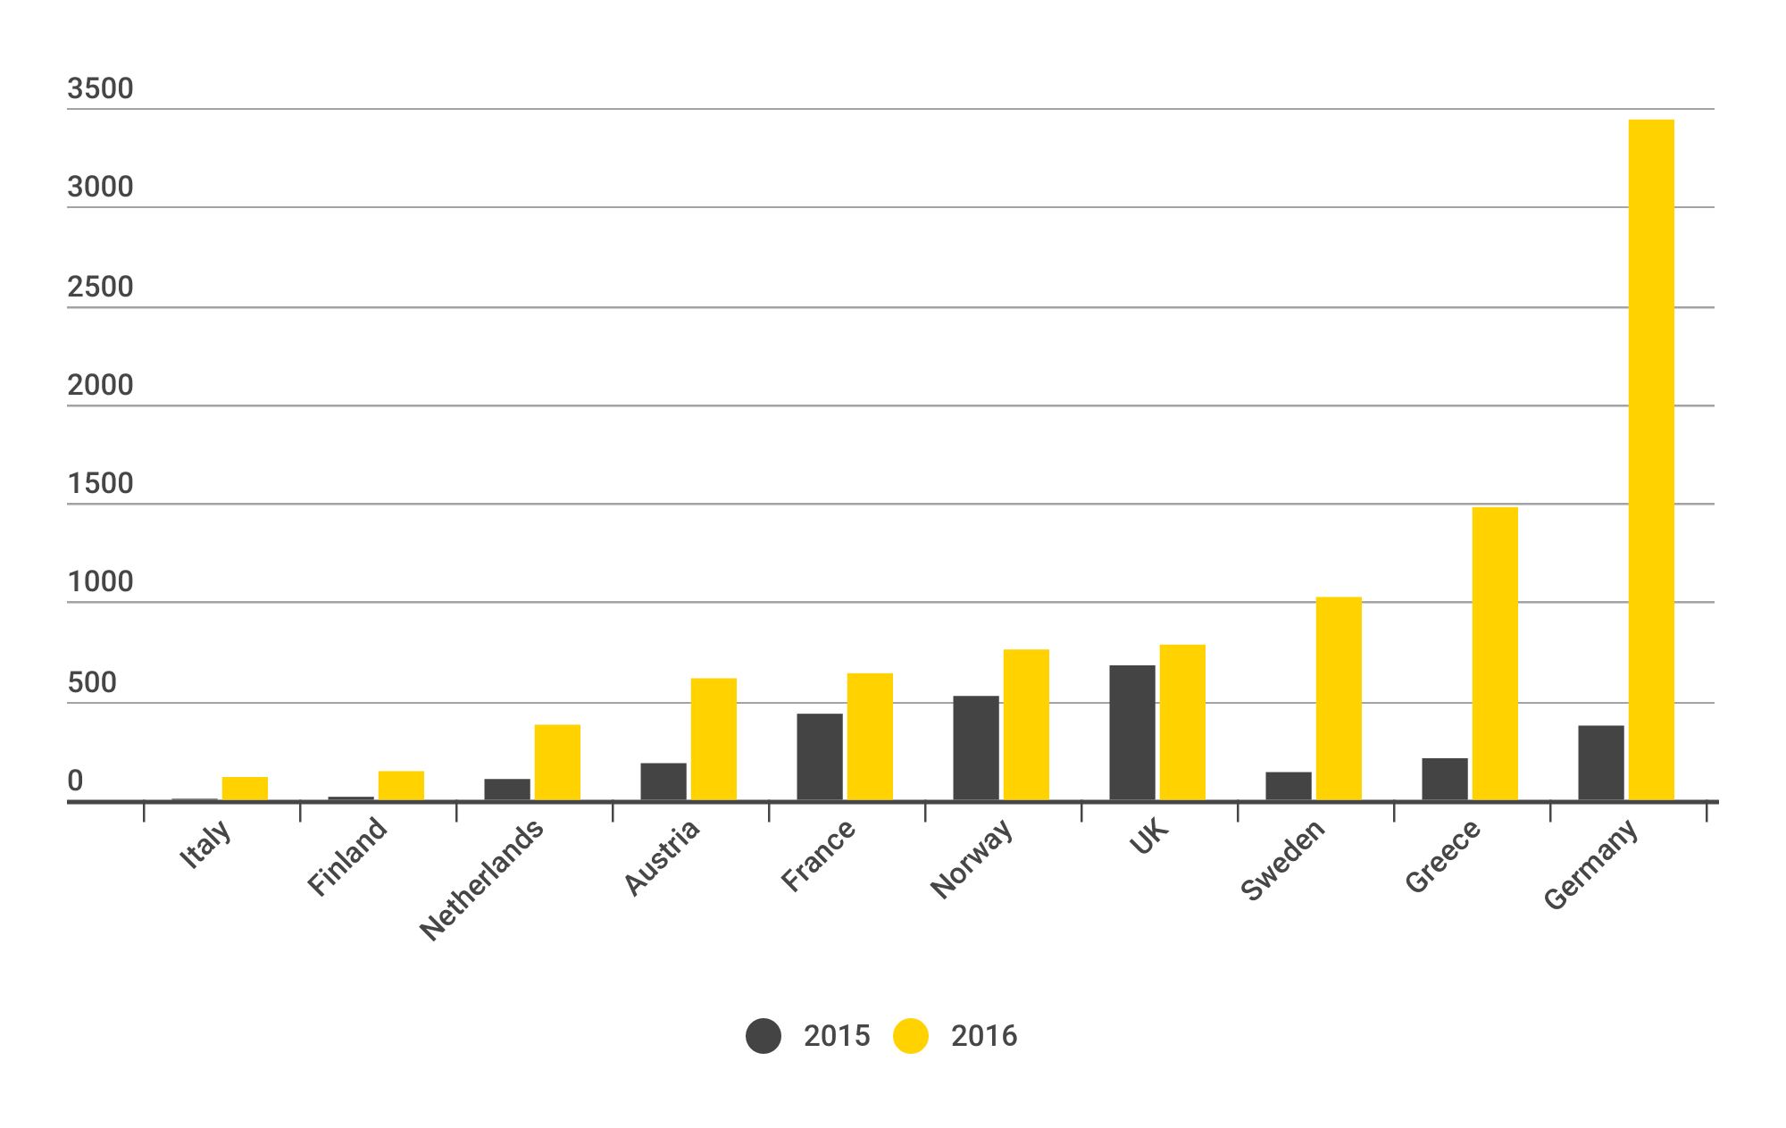

***
The increasing numbers of returns of people to Afghanistan, when contrasted with the increasing number of civilian casualties, raise serious questions about the decision-making processes of European authorities.
Civilian Casualties in Afghanistan and Returns from Europe, 2013-2016
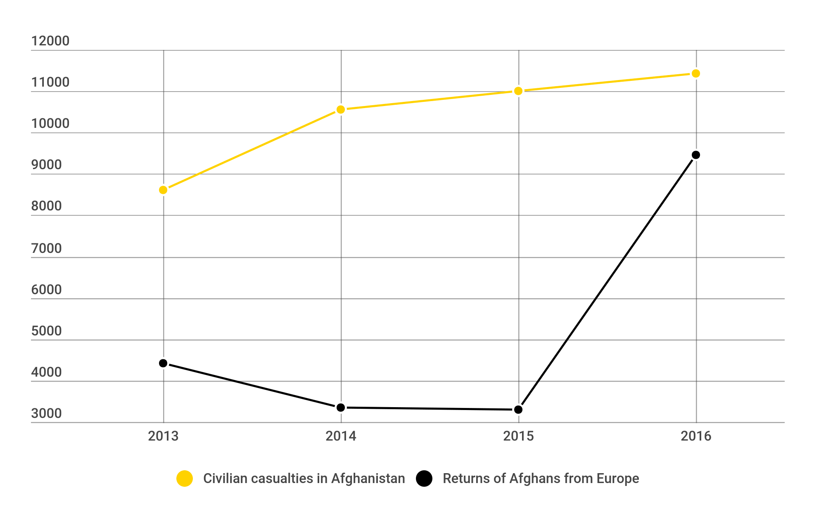

Evidently there is a gap between the objective facts on the ground in Afghanistan, and the actions and policies of the EU and European governments towards Afghan asylum-seekers. Why this incoherence between reality in Afghanistan and European authorities’ treatment of people who have fled the country?
One key factor would appear to be political developments in Europe. In 2015, an unprecedented number of people – over one million – reached Europe irregularly, mainly on dangerous boat journeys from Turkey. Approximately 20% of these people (200,000) were from Afghanistan. Notwithstanding the fact that these numbers are small compared to the millions of refugees living in countries like Iran and Pakistan, the EU and many national governments in Europe responded by actively trying to prevent more asylum-seekers from arriving irregularly on European soil.
This is the context in which a document called the “EU-Afghanistan Joint Way Forward” (Joint Way Forward) was negotiated and signed in October 2016. The document aims to facilitate the return of Afghan nationals from all European Member States to Afghanistan.
Officially, the Joint Way Forward is premised on solidarity and collective efforts to address the migration challenges faced by both Afghanistan and the EU. The document explicitly states that the development aid provided to Afghanistan is independent of the funds meant for return programmes and reintegration assistance.
Notwithstanding the Joint Way Forward’s rhetoric of solidarity and cooperation, in fact the agreement puts pressure on Afghanistan to accept large numbers of returns. Afghanistan’s Minister of Finance, Eklil Hakimi, has been quoted telling the Afghan parliament: “If Afghanistan does not cooperate with EU countries on the refugee crisis, this will negatively impact the amount of aid allocated to Afghanistan.” Similarly, a confidential Afghan government source called the Joint Way Forward a “poisoned cup” that Afghanistan was forced to drink in order to receive development aid. The country is highly aid-dependent, with nearly 70% of Afghanistan's annual income dependent upon international donors. In a leaked document from March 2016, EU agencies stated that leverage at an upcoming October 2016 aid conference for Afghanistan (at which the Joint Way Forward was signed) “should be used as a positive incentive for the implementation of the Joint Way Forward.” The document also specified that a EUR 200 million state-building contract in Afghanistan “is intended to be made migration sensitive, probably through one indicator linking it to the Government’s policy on migration and return and possibly to the implementation of the ‘Joint Way Forward’.” In the document, EU agencies also acknowledged Afghanistan’s “worsening security situation and threats to which people are exposed,” as well as the likelihood that “record levels of terrorist attacks and civilian casualties” will increase, but nevertheless stated that “more than 80,000 persons could potentially need to be returned in the near future.”
The message is clear: deportations will increase, irrespective of the dangers to which people are exposed upon return.
To effect these returns, European countries have arbitrarily called some areas of Afghanistan “safe,” relying on the idea of an “Internal Flight Alternative” (IFA). In other words, the authorities recognise that the person’s province of origin is dangerous, but expect them to live elsewhere in the country. For example, several European countries consider Kabul to be a safe place. However, UNAMA reports that the province continues to be the site of the highest number of civilian casualties, mainly in Kabul city, accounting for 19% of all civilian casualties in the entire country.
The concept of IFA is both legally questionable and – in the case of Afghanistan – factually unsound. The UN Refugee Agency, UNHCR, as expressed serious reservations about the concept of IFA, which has no basis in the Convention Relating to the Status of Refugees. Furthermore, UN and other expert reports make clear that civilian casualties and serious security incidents are occurring across Afghanistan, from North to South and East to West. The security situation is volatile and the multiple armed groups operating in the country are seeking to hold, capture or recapture territory. There is no credible possibility of durable IFA option.
European countries’ determination to return people to Afghanistan regardless of widespread insecurity, is clear in their efforts to deport vulnerable young people. This includes unaccompanied children, as well as young adults who originally reached Europe as unaccompanied children. Children face the same dangers as everyone in Afghanistan, but also face additional risks, of which the European authorities are aware. The EU-funded, IOM-run “European Reintegration Network Programme for Afghanistan” has acknowledged the particular vulnerability of unaccompanied children returned from Europe, noting the complete absence of national legislation governing their care, or of local or international NGOs that could provide them with support.
***
Afghanistan is deeply unsafe, and has become more so in recent years. Yet European countries are returning people to Afghanistan in increasingly large numbers, even as the violence in the country escalates. At present, given the grave security and human rights situation across the country, all returns to Afghanistan constitute refoulement. For the principle of non-refoulement to be breached, it is not necessary for serious harm to ensue: the human rights violation takes place when someone is returned to a real risk of such harm. European governments have remained wilfully blind to the dangers to which returnees are exposed, and – together with the EU – are putting Afghanistan under tremendous pressure to accept large numbers of returnees. Prioritizing deportations, heedless of the evidence, is reckless and illegal.
Amnesty International is calling on all European countries to implement a moratorium on returns to Afghanistan until they can take place in safety and dignity. The organization also recommends that UNHCR call for such a moratorium. In addition, Amnesty International urges the Government of Afghanistan and IOM not to cooperate with the returns of people from Europe to Afghanistan.

Amnesty international
is a global movement
for human rights.
When injustice happens
to one person, it
matters to us all.

Forced back to danger
Asylum-seekers returned from Europe to Afghanistan
The conflict gripping Afghanistan is widespread and volatile. Tens of thousands of civilians have been killed or injured, and a wide range of people are at additional risk of other serious human rights violations such as persecution or torture. No part of the country can be considered safe.
European countries and the European Union have remained wilfully blind to these dangers, and are putting tremendous pressure on Afghanistan to accept large numbers of returns. Returns are increasing, even as dangers in the country have become more severe. To effect these returns, European countries have arbitrarily called some areas of Afghanistan “safe,” including Kabul, which is currently the most dangerous part of the country for civilians.
The returns from Europe, happening despite the evidence on the ground in Afghanistan, amount to refoulement – that is, transfers to a risk of serious human rights violations. At present, given the grave security and human rights situation across the country, all returns violate the international legal principle of non-refoulement.
Amnesty International is calling for a moratorium on all returns to Afghanistan, until they can take place in safety and dignity.

* All interviewees’ names have been changed to protect them.

